

School of Informatics and IT
Diploma in Big Data & Analytics

Major Project Final Report

Project Title:

Smart Environmental Monitoring Device with Cloud Analytics

Submitted By:

Rachel Robin Fernandes 2200701G

Supervisor:

<Title>Mr. Zaw Htet Wai, Temasek Polytechnic, Temasek Polytechnic

Declaration of Originality

I am the originator of this work and I have appropriately acknowledged all other original sources used as my reference for this work.

I understand that Plagiarism is the act of taking and using the whole or any part of another person’s work, including work generated by AI, and presenting it as my own.

I understand that Plagiarism is an academic offence
If I am found to have committed or abetted the offence of plagiarism in relation to this submitted work, disciplinary action will be enforced.

√ | I Agree (Please Tick )

Student Name (Matric Number): Rachel Robin Fernandes (2200701G)

Submission Date: 13th Dec 2024

Declaration on the use of Generative AI tools for assignments

Describe how you have used Generative AI tools such as ChatGPT or Dall.E-2 in your assignment.

Show snapshots of the conversations with the AI tool (i.e., the prompts you used and the response you get from the AI tool).

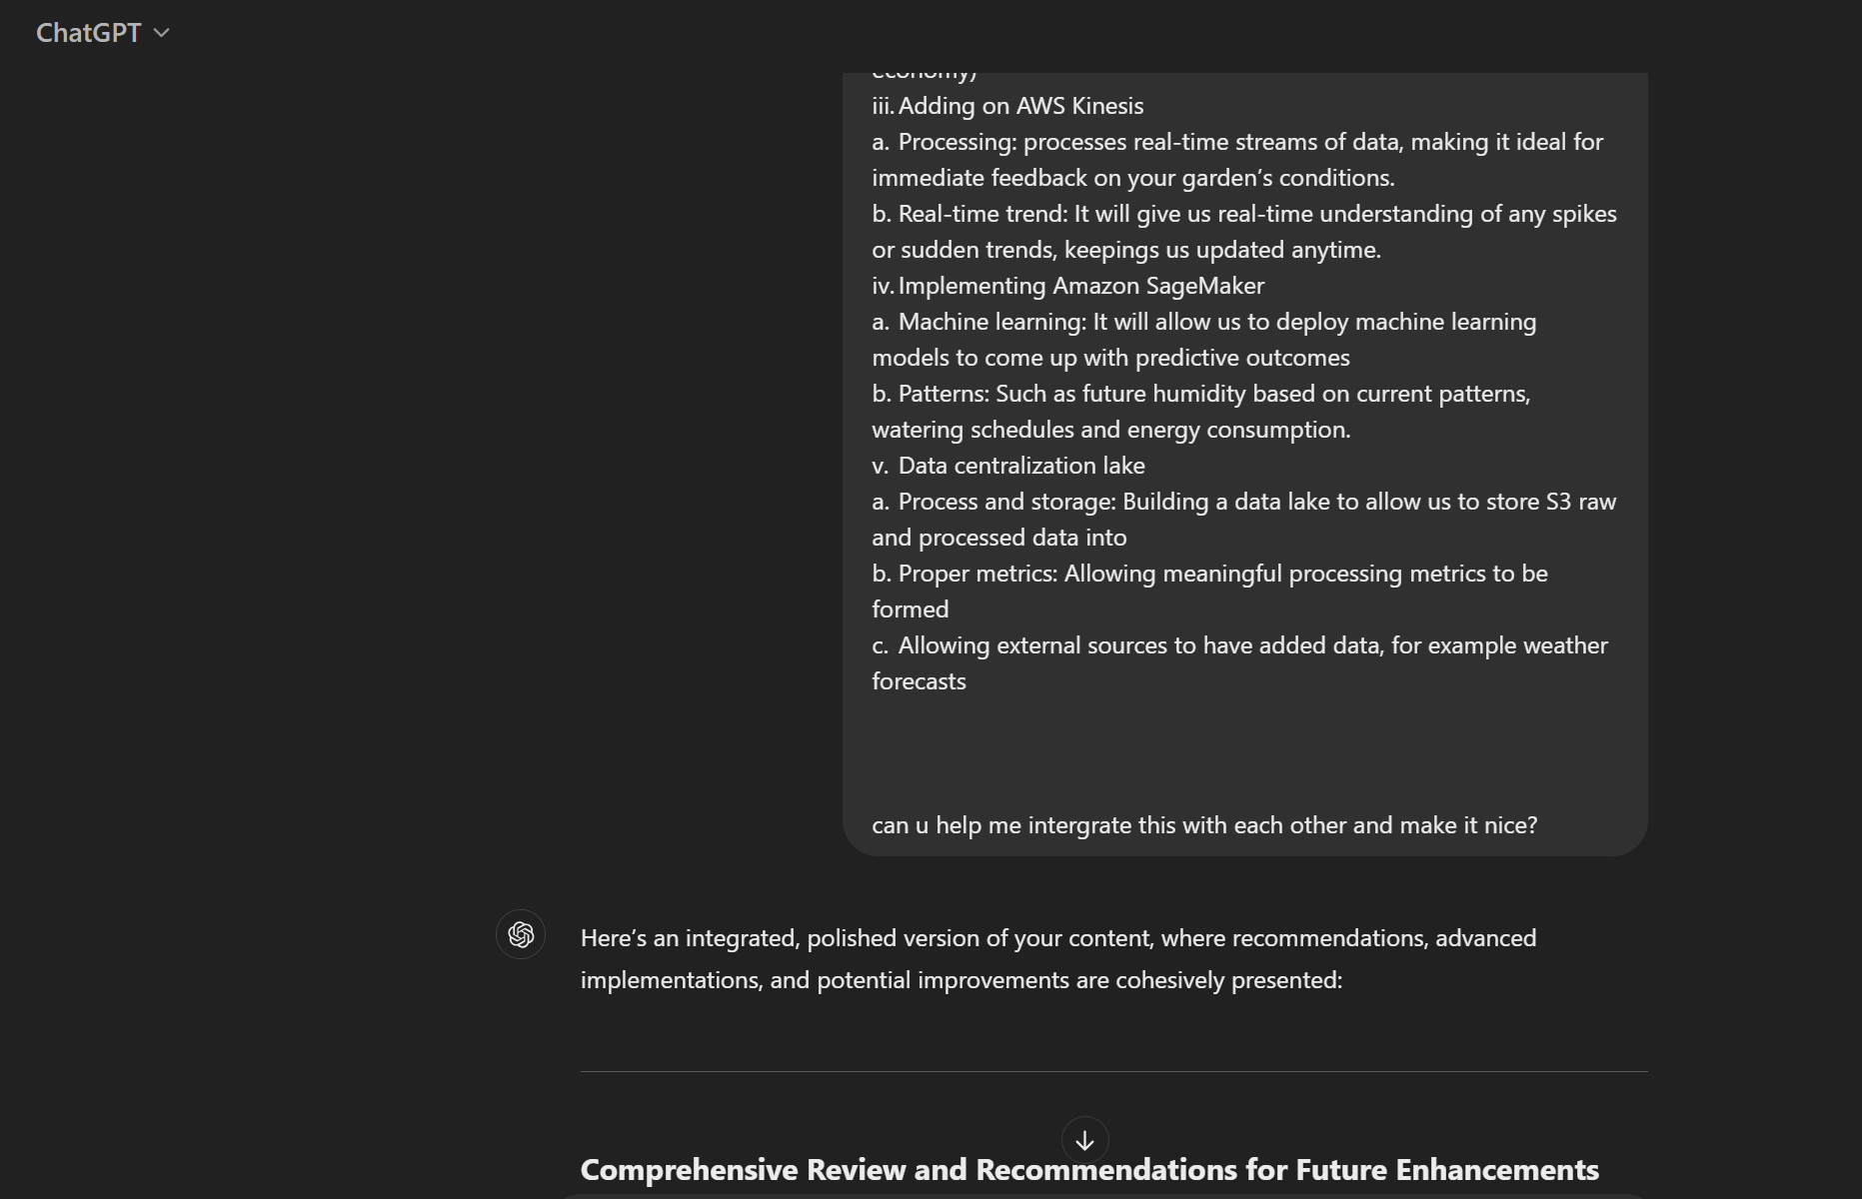

How do you indicate the reference?
The content generated by AI tools are not retrievable except by the user who generated them, so they are considered non-recoverable sources. For non-recoverable sources:
- do not include in a reference list
- cite within the text as personal communications or correspondence
Based on APA 7th edition referencing format,
(Communicator, personal communication, Month Day, year)

E.g. (Paraphrase from OpenAI's ChatGPT AI language model, personal communication, March 8, 2023).

Important Note:

- Do not copy answers produced by the AI tool in totality as it is considered as plagiarism.

- Do not rely on any information produced by the AI tool blindly. You should always verify the answer with other sources. Do not assume that these answers provided by the AI tool are correct.

- To achieve quality outputs from the AI tool, you should provide good prompt that is clear and specific. Be precise and provide context.

- Avoid asking open-ended questions.

How to prepare the citation for references:
https://tp.libguides.com/apa
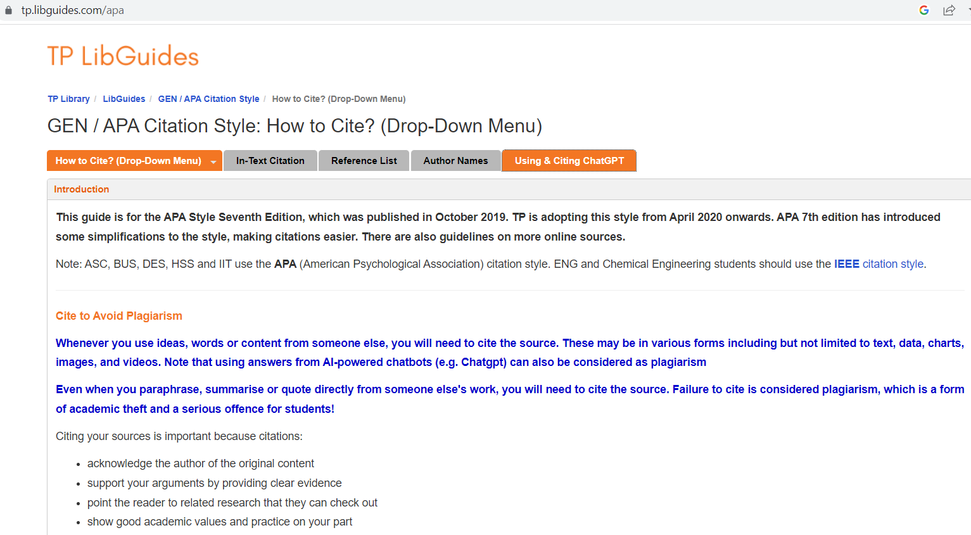

Table of Contents

Major Project Final Report 0
Declaration of Originality 1
Table of Contents 3
Acknowledgements 5
Chapter 1: Introduction 6
Background of the project 6
Problems Identified 6
Objectives of the project 6
Scope of the project 7
Business analytics problem 7
Chapter 2 8
Business Solutions 8
Internet of Things (IoT) Establishment 10
i. Software Selection - UIFlow 2.0.0 10
ii. Installation and Connection Process 10
iii. Challenges Encountered 11
iv. Sensor Connection Process 11
v. Technical Implementation 12
vi. GPIO Mapping for M5Stack Core2 Grove Ports 12
vii. Sensor Data Validation 13
viii. Best Practices Applied for Reliable Data 13
ix. Added Features 13
x. Challenges Encountered 14
Iot Core 2 to AWS IoT core connection 14
Wi-Fi and MQTT configurations 14
M5 Stack Core 2 Connection to AWS IOT 15
Challenges Encountered 19
Successful AWS code for Micro Python 22
i. What Worked or Partially Worked 22
ii. Tackling the issues 24
iii. Working configurations with Blocky 24
iv. Visual Screen 25
v. Connection Setup 25
vi. Publishing Data 25
vii. Receiving Data 26
viii. IoT and M5 stack core 2 Troubles 26
AWS Pipeline 26
Amazon IoT Core 27
Amazon S3 27
AWS Lambda 28
AWS Athena 28
AWS Glue 28
Amazon EventBridge 29
AWS Step Functions 29
Amazon CloudWatch 29
Analysis Tools: Looker, Power BI, Tableau 29
Instructions: Connecting AWS IoT Core to AWS S3 30
Create an S3 Bucket 30
Configure CORS Settings 30
Set the Bucket Policy 30
Configure AWS IoT Core 31
Test the Connection 31
Connection of the S3 Bucket to AWS Lambda to S3 bucket 31
Challenges Established 35
Establishing a Connection from S3 to Athena 36
Establishing a connection from AWS Athena to the Step function 37
Step Function Implementation 38
Execution Input 43
Final Working Solution: Step Functions with Lambda Intermediary 43
Challenges Encountered 44
EventBridge Integration 44
Challenges Encountered 45
Summary of Issues and Adjustments 45
Athena to Power BI 46
How to connect AWS Athena to Power BI 46
Power BI 47
1. Sum of Greenhouse Gas Consumption (kg CO₂) and Ambient Humidity (%) by Weather Data 48
2. Average of Ambient Temperature (°C) by Species 48
3. Sum of Light Intensity (lux) by Hour of Day and Species 49
4. Sum of Ambient Temperature (°C) by Weather Data and Fan Status 49
5. Average of Light Intensity (lux) by Species (Pie Chart) 50
6. Count of Soil Temperature (°C), Soil Moisture (%), and Ambient Temperature (°C) by Species 50
Chapter 3 Evaluation/Review 50
Product 50
Review 50
Process 52
Process Overview 52
Initial Research and Learning 52
Sensor Configuration 52
UIFlow and AWS IoT Integration 52
AWS Pipeline Implementation 52
EventBridge and Analysis 53
Recommendations for Improvement 53
Recommendations for System Enhancement 53
Advanced Features for Future Development 54
Reflection 55
Lessons Learnt and Insights Gained 55
References/ Bibliography 57
Appendix A1: Terms of Reference 58
Appendix A2: Weekly Progress Report 58

Acknowledgements
I would like to thank my supervisor, Mr Zaw, for his guidance and support in reviewing the MP and guiding me down the right path when in doubt. I thank my teammates Timothy Alexander Tirtamaya from Big Data Analytics, Chan Li Kai Alexander, and Lim Zhi Wen from Information Technology for assisting throughout the project.
Abstract
Urban environments face increasing challenges in sustainability and efficient space utilization. This project aims to develop an automated system to maintain optimal growing conditions in vertical gardens, addressing the specific needs of HDB communities, eldercare homes, and busy households where manual monitoring is impractical. Objectives include creating an IoT-based edge solution using the M5Stack Core2 to collect environmental data, integrating AWS IoT Core for cloud connectivity, and generating actionable insights through data visualization to support both business and technical perspectives.
The scope of the project includes automating fan usage based on real-time environmental parameters—temperature, humidity, and light intensity—ensuring energy efficiency, plant health, and reduced human intervention. Visualizations further enhance decision-making by bridging technical details with practical business applications.
The project successfully met its objectives, demonstrating its ability to automate environmental control while contributing to sustainability goals. Key findings highlight the system’s effectiveness and potential scalability, with recommendations for advanced analytics using AWS tools, improved interfaces, and enhanced modularity for larger systems. This report concludes with the solution’s significant potential to support urban farming and reduce carbon emissions, fostering a sustainable future.

Chapter 1: Introduction

Background of the project
Background:
Urban environments increasingly face challenges related to sustainability and efficient space utilization. A team of data analysts was tasked with exploring solutions for sustainable agricultural practices within these settings. Among the ideas proposed, vertical gardens stood out for their potential to improve air quality, reduce urban heat, and enable space-efficient farming. However, maintaining optimal conditions such as temperature, humidity, and light is crucial for plant health.
This is particularly challenging in HDB communities, eldercare homes, and busy households where manual monitoring is labour-intensive and impractical, especially for elderly residents. Traditional methods often rely on basic automation, which lacks adaptability for varying plant species' needs.
By integrating IoT sensors to monitor soil moisture, ambient temperature, humidity, and light intensity, this project aims to automate fan usage to maintain ideal growing conditions. This ensures energy efficiency, minimizes human intervention, and supports urban farming initiatives, ultimately contributing to reduced carbon emissions and fostering a greener future.

Problems Identified
Problem Statement: How can we automate fan usage to regulate temperature and humidity for diverse plant species in vertical gardens, particularly for HDB communities, eldercare homes, and households where adults are away for extended periods? This solution aims to support the elderly and promote sustainable urban farming, with potential scalability to reduce carbon emissions, and greenhouse gases, and foster a greener future on a larger scale.

Objectives of the project
- Creating an edge solution using AWS M5 Stack (collecting the environmental data such as temp, humidity, and light) either in UIFlow
- Working with the team to collect analysable and useful data
- Upload the data to the cloud (using AWS IoT Core or other relevant cloud services)
- Creating a Control Centre UI (user interface) on M5 Stack for user-configurable settings/adjustments such as data-sync interval, Wi-Fi config, etc. (Optional)
Solution Goal: Use sensor data to automate fan activation, ensuring optimal temperature and humidity for plant health in vertical gardening systems.

Scope of the project
This project focuses on leveraging IoT technology to automate fan usage in vertical gardens, ensuring optimal temperature and humidity for plant health while minimizing energy consumption. The solution is tailored for HDB communities, eldercare homes, and households with limited human intervention. Key activities include:
- Sensor Integration: Real-time data collection from sensors (e.g., soil moisture, temperature, humidity, light intensity).
- Automation: Developing a system that triggers fans based on environmental data to optimize energy use.
- Metrics and Analytics: Defining key performance indicators such as plant growth, energy efficiency, and greenhouse gas reduction while analyzing trends for data-driven decisions.
- Scalability and Community Customization: Adapting solutions for diverse urban environments and evaluating scalability for larger urban farming initiatives.
Excluded from the scope are large-scale agricultural systems, deep species-specific optimization, manual monitoring, and commercialization beyond the prototype stage. The project strictly focuses on controlled vertical garden environments and automation within these parameters.

Business analytics problem

Objective
To leverage IoT sensor data to automate fan usage, optimize energy efficiency, and maintain optimal conditions for plant growth in urban vertical gardens, ensuring sustainability and scalability for diverse communities.
• Descriptive Analytics:
- What are the trends in temperature, humidity, and soil moisture across different environments?
- How much energy is consumed daily by the automated system?
• Predictive Analytics:
- Can environmental conditions requiring fan activation be forecasted?
- Which plant species thrive best under specific environmental conditions?
• Prescriptive Analytics:
- What is the ideal fan runtime to balance energy efficiency and plant health?
- How can the system be scaled to maximize greenhouse gas reductions?
By leveraging IoT sensor data, this analytics framework ensures the solution is optimized for plant growth, energy efficiency, and sustainability.

Chapter 2

Business Solutions
The problem with a lot of places especially in countries like Singapore where space is a limitation is the lack of space for urbanization and greenery, with global warnings playing an impending role in our lives affecting the atmosphere, while indirectly affecting our business due to energy cost spikes and supply chain disruptions in the long run. Furthermore, in our modern society, people prioritize sustainable practices.

For this project the main basis is ensuring it focuses on the business aspects, this is beneficial to a lot of businesses due to several factors including strengthening cooperate social responsibilities, reduction of operations costs, research development in market leadership and finally scalability with revenue potentials.

- Strengthening Cooperate Social Responsibilities
- Environmental impacts – this will cause the reduction of carbon footprints; due to the support from vertical farming systems, it will reduce greenhouse gas emissions which indirectly minimizes the drastic need for transportation and cooling.
- Waste reduction – it would promote higher water efficiency usage as well as enhance the sustainability records for several businesses.
- Brand reputation – eco branding and alignment with ESG goals are attractive to potential customers as well as boosting brand image for people who tend to lean towards more earth-friendly alternatives.
- Community impact - installing these vertical gardens in elderly homes and schools allows us to install valuable values into the hearts of young minds while fostering a healthy activity for the elderly to engage in. While improving air quality and a sense of achievement for fresh produce grown over time.

- Reducing Operational Costs
- Energy savings – smart automation is implemented for the reduction of electrical bills while reducing the need for human labour.
- Food and supply costs – For operational businesses that need consumables this can help cut down their dependencies on supply chains.
- Water efficiency – due to the water systems being automated this allows very minimal water, furthermore, the water recycling system allows water to be reused over time.
- Reduced maintenance cost - traditional gardens, and IoT-driven systems require less manual labour for monitoring and adjustment, reducing the need for full-time staff.
- Sustainable incentives - Companies might qualify for tax breaks, rebates, or subsidies for adopting energy-efficient and sustainable technologies.

- Research Development In Market Leadership
- Data insights for innovation – using urban farming we can drive R&D into sustainable agriculture leading to further innovations in crop yield optimization.
- Technological Advancements - Leveraging this technology can create intellectual property (IP), such as proprietary algorithms for energy-efficient automation, which can then be monetized through licensing.
- Cross-Sector Partnerships - Engaging with tech, agricultural, or real estate sectors can drive mutual growth, enabling businesses to co-create scalable urban farming models.
- Academic and Policy Influence - Partnering with universities for research or collaborating on urban farming policies can further enhance credibility and influence.

- Scalability and Revenue Potential
- Commercialization of technology - Companies can package and sell vertical gardening systems as standalone kits or subscription-based services to homeowners, businesses, or community organizations.
- White-Label Opportunities - Offering customizable solutions to other businesses for rebranding can open additional revenue streams.
- Expansion into New Markets - Urban Development Projects Scaling vertical gardens for commercial spaces like malls, airports, and office parks can provide sustainable, visually appealing solutions while fulfilling ESG requirements for developers.
- Smart city Integration – Urban farming systems can be integrated into the smart city initiatives aligning with the current global trends for sustainable urbanization.
- Recurring revenue modes – subscriptions offering ongoing monitoring maintenance for analytics and subscription services to price predictable revenue streaming.
- Healthcare and Wellness - Vertical gardens can be marketed to hospitals, eldercare facilities, and wellness centres as therapeutic and sustainable installations.
- Hospitality and Tourism - Hotels and resorts can use vertical gardens as both a feature and a resource, enhancing guest experiences while reducing their environmental impact.

Internet of Things (IoT) Establishment
- Software Selection - UIFlow 2.0.0
After evaluating multiple options, we decided to use UIFlow 2.0.0 as our development platform. Initially, we tested Arduino and Raspberry Pi, but both encountered compatibility issues with our hardware setup. For example, we faced challenges with library support and lack of specific device features required for our project. After extensive trial and error, we found that UIFlow offered the best balance between ease of use and functionality, making it the most compatible with our device. This decision allowed us to meet our goal of quick and efficient development.
Additionally, after considering both Wi-Fi and USB connections, we opted for USB as it provided a more stable and reliable connection, reducing troubleshooting time related to network issues. This choice helped ensure seamless communication between the M5Stack Core2 and our system.
- Installation and Connection Process
Once we selected UI Flow, we focused on establishing a reliable connection between the M5Stack Core2 and our system. Below are the steps we followed:
- Installed the M5Stack USB driver for Windows: This ensured that we could connect the M5Stack device to our computer.
- Chose USB over Wi-Fi for connectivity: To prioritize efficiency and minimize potential issues, we opted for a USB connection instead of Wi-Fi.
The detailed process for installing and configuring the M5Stack Core2 involved the following:
- Charging the M5Stack Core2: Ensured the device was fully charged for use.
- Wi-Fi Configuration: Examined and adjusted the device’s Wi-Fi settings for compatibility.
- USB Settings: Configured the USB settings to ensure compatibility with the device.
- Experimented with the M5Burner to manage firmware installation.
- Driver Updates: Checked Device Manager for outdated drivers, focusing on USB-to-UART connections, and updated missing components with Silicon Labs drivers (CP210x USB to UART Bridge VCP Drivers).
- Resolved missing ports with Silicon Labs drivers (CP210x USB to UART Bridge VCP Drivers) to update any obsolete components, ensuring proper communication with M5Burner and using the latest firmware for Core2.
- Identified the correct port and established a connection.
- Scanned for hardware changes in Device Manager to confirm proper setup.
- Configured Wi-Fi and API settings consistently across the application and device to ensure seamless communication.
- Burned the configurations to the M5Stack, prompting an automatic restart of the device.
- Downloaded the UIFlow 2.0 desktop IDE and created a new project file for the M5Stack.
- Experimented with sound and port connections using UIFlow.
- Tried to find the sounds of each port for functionality and workability
- Challenges Encountered
Throughout this process, we encountered a few challenges:
- Device blackouts: The device blacked out several times due to pre-existing Wi-Fi settings, which caused issues. We needed to bypass the current Wi-Fi configuration and reboot the machine. This was resolved with the help of M5Stack documentation and AWS resources.
- Burner connection issues: Outdated ports and missing software made connecting to the M5Burner difficult. We experimented with different ports and drivers before identifying the optimal setup for our needs.
- Testing across multiple laptops: To overcome port issues, we tried configuring two different laptops. After multiple adjustments, including changes to burner settings, USB configurations, and Wi-Fi/passwords, one of the laptops was found to be compatible with the M5Stack.
- Limited documentation for UIFlow 2.0: The lack of comprehensive documentation and video resources for UIFlow 2.0 caused some confusion. We addressed this by researching older versions of the software and piecing together the relevant information.
- Sensor Connection Process
- Initial Testing:
  - Port Sound Verification: We began by connecting each sensor to different ports and listening for distinct sounds. This method confirmed the presence of current flow through the device and validated that the sensors were capable of generating measurable values.
- Port Configuration:
  - Extension Unit Utilization: Using the provided extension unit, we connected Port C to the EVN III and the Grove Hub (extender), while the Earth Monitor was connected to Port B.
- Technical Implementation
- Imports and Initialization:
  - Libraries:
    - m5stack, m5ui, uiflow: For M5Stack device operations.
    - time: To handle delays.
  - Sensor Configuration:
    - SENSOR_PIN: Configured to GPIO39 (Port B) for analogue input.
    - CALIBRATION_MIN & CALIBRATION_MAX: Set based on sensor specifications to translate raw ADC values into meaningful data.
- Sensor Data Handling:
  - Reading Sensor Data:
    - read_sensor(pin): Captures the raw analogy value, normalizes it, and handles exceptions.
    - average_readings(pin, num_samples, delay_ms): Averages multiple readings to minimize noise and enhance reliability.
  - Main Loop Operations:
    - Continuously reads and averages sensor data, converts it to a percentage, and displays it on both the M5Stack Core2 screen and the serial monitor.
    - Implements error handling to display messages if sensor data retrieval fails.
- Code Deployment:
  - Uploading the Code:
    - Copied the MicroPython script into the UIFlow MicroPython editor.
    - Uploaded the script to the M5Stack Core2 using the “Upload” or “Run” button.
  - Monitoring Outputs:
    - Observed real-time sensor readings on the M5Stack Core2’s screen.
    - Utilized the serial monitor in UIFlow for debugging and monitoring.
  - The M5Stack Core2's screen.
- GPIO Mapping for M5Stack Core2 Grove Ports
Grove Port | GPIO Pin | ADC Channel | Notes
Port A | GPIO35 | ADC1_CH7 | Input-only, no internal pull-up/down resistors
Port B | GPIO39 | ADC1_CH3 | Input-only, no internal pull-up/down resistors
Port C | GPIO34 | ADC1_CH6 | Input-only, no internal pull-up/down resistors
Port D | GPIO36 | ADC1_CH0 | Input-only, no internal pull-up/down resistors
Characteristics of GPIO36:
- Input-Only Pin: Cannot be used for output operations.
- No Internal Pull-up/down Resistors: External biasing is required if the sensor needs it.
- Voltage Range: Supports 0-3.3V to prevent GPIO damage.
- ADC Resolution: Provides up to 12-bit resolution (0-4095). Calibration may be necessary for accurate data mapping.
- Sensor Data Validation
- Raw Value Analysis:
  - Tabulated and compared raw ADC values based on research to ensure accuracy.
  - Determined raw ADC values for humidity and temperature, applying a scaling function for quality results.
- Temperature Calculation:
  - Adopted the formula: Temperature=m×Raw ADC Value+b\text{Temperature} = m \times \text{Raw ADC Value} + bTemperature=m×Raw ADC Value+b
  - Calculations:
    - Slope (m): m=40−202500−1500=201000=0.02°C/ADC unit = \frac{40 - 20}{2500 - 1500} = \frac{20}{1000} = 0.02 \degree C/\text{ADC unit}m=2500−150040−20​=100020​=0.02°C/ADC unit
    - Intercept (b): 20=0.02×1500+b20=30+bb=−1020 = 0.02 \times 1500 + b \\ 20 = 30 + b \\ b = -1020=0.02×1500+b20=30+bb=−10
    - Observed Raw ADC Values:
      - At 25°C: Raw ADC ≈ 1500
      - At 30°C: Raw ADC ≈ 1800
      - At 35°C: Raw ADC ≈ 2100
    - Slope Determination: m=30−251800−1500=5300≈0.0167°C/ADC unitm = \frac{30 - 25}{1800 - 1500} = \frac{5}{300} \approx 0.0167 \degree C/\text{ADC unit}m=1800−150030−25​=3005​≈0.0167°C/ADC unit
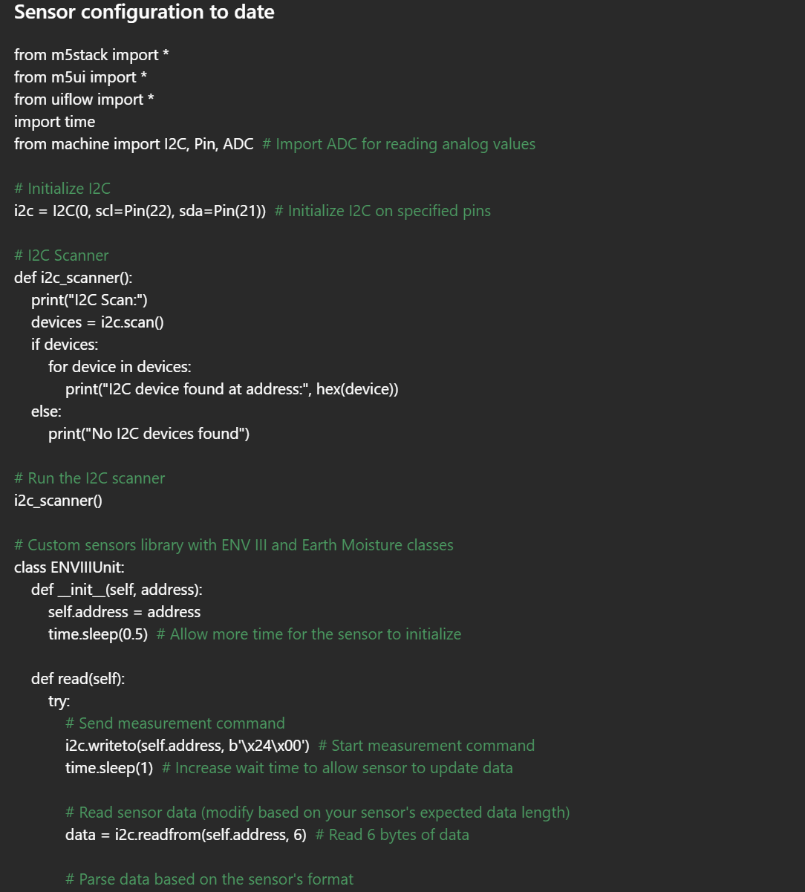
- Best Practices Applied for Reliable Data
- Calibration:
  - Ensured CALIBRATION_MIN and CALIBRATION_MAX are accurately set based on sensor specifications. Performed calibration routines to determine precise values.
- Stabilizing Readings:
  - Averaging: Employed multiple samples and averaged them to reduce transient noise.
  - Delays: Implemented appropriate delays between readings to allow sensor stabilization.
- Error Handling:
  - Incorporated try-except blocks to manage exceptions during sensor readings, preventing unexpected program crashes.
- Power Supply Stability:
  - Verified that sensors receive a stable power supply to avoid voltage fluctuations that could lead to unreliable readings.
- Added Features
- Data Logging:
  - Planned modifications to log data to an SD card or transmit it to a cloud service for long-term monitoring.
- Alerts:
  - Implemented threshold-based alerts to notify when sensor readings exceed acceptable limits.
- User Interface Improvements:
  - Enhanced the display by adding graphs and more detailed information on
- Challenges Encountered
- No Data Displayed:
  - Verified the physical connections between the Earth Monitor sensor and Port B.
  - Ensured SENSOR_PIN was correctly set to GPIO39, which was appropriate for analogue input.
- Erratic Readings:
  - Checked for electrical noise in the setup and considered adding capacitors if necessary.
  - Confirmed proper sensor calibration.
- Sensor Not Responding:
  - Verified sensor compatibility with the M5Stack Core2.
  - Checked if the sensor requires specific initialization commands as per the sensor’s datasheet.

User manual guide
To access the user manual press the hyperlink
MP Setup User Manual.docx

Iot Core 2 to AWS IoT core connection

Wi-Fi and MQTT configurations
- Power On the M5Stack Core2:
  - Turn on the M5Stack Core2 and press the UI Flow button. A prompt will appear, asking you to choose between USB and Wi-Fi.
- Select Wi-Fi Mode:
  - Choose the Wi-Fi option. The M5Stack Core2 will reboot and display a page with an SSID and IP address.
- Connect to SSID:
  - On your computer, connect to the M5Stack’s SSID (displayed on the device screen). Ensure you are using a browser that is not restricted by a firewall.
- Access the Wi-Fi Configuration Page:
  - Open the browser and enter the IP address provided by the M5Stack Core2. This will direct you to the Wi-Fi configuration page.
- Enter Wi-Fi Credentials:
  - Input the desired Wi-Fi network credentials. In this case, connect to your personal hotspot “Rachel” by entering the correct password, then press Configure.
- Reboot and Apply Settings:
  - The M5Stack Core2 will reboot to apply the new Wi-Fi settings.
- API Key Display:
  - Once rebooted, the device will display an API key, which is essential for connecting with UIFlow or any other integrated services.

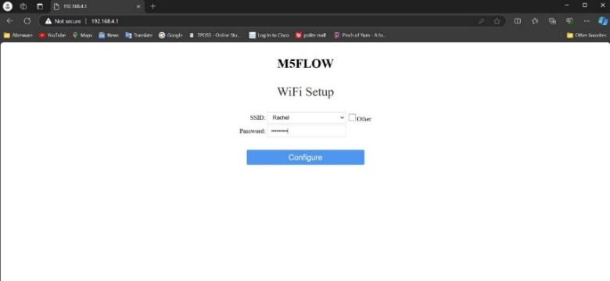
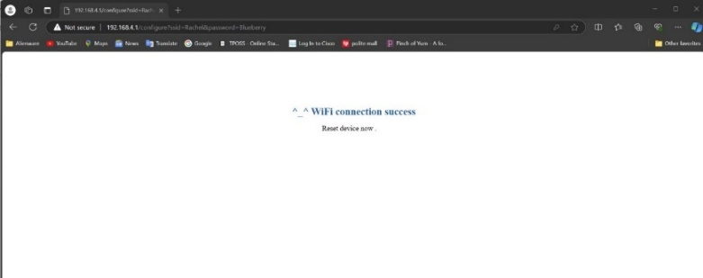
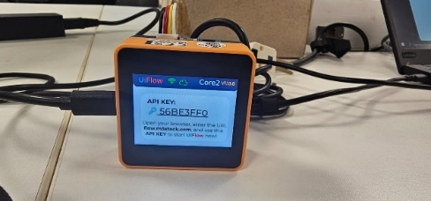

MQTT configurations
This process was done in the AWS IoT Core module, where we need to connect the M5 Stack Device to the cloud services in AWS. We begin by creating the policy to later be implemented in a "Thing" in AWS IoT, which would be connected to the M5 Stack. However, before finalizing the creation of the policy. I had to download the files of the Private Key and Certificate for that policy to establish the connection. Which was stored in the file explorer as well as in the m5 stacks file also known as the "/flash/".

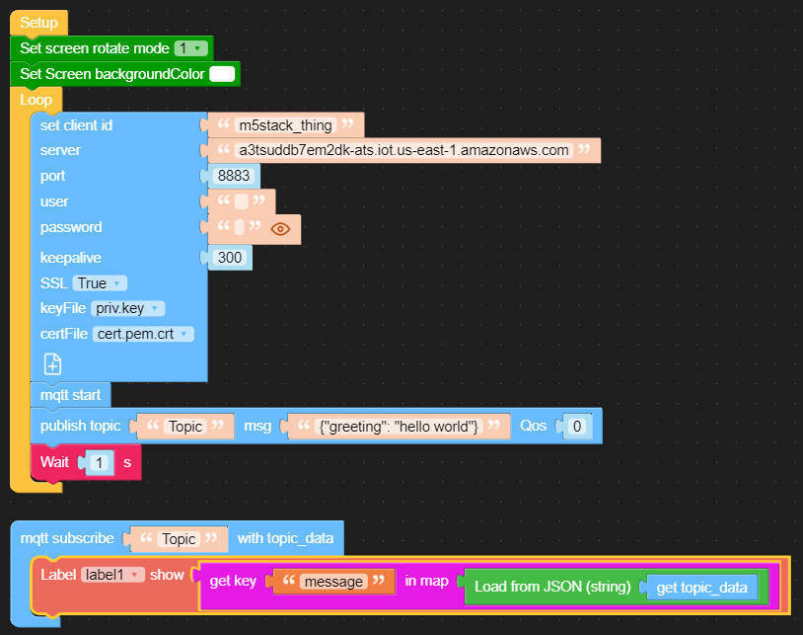

M5 Stack Core 2 Connection to AWS IOT

- Open the AWS learner Lab, open up AWS IOT and go to things that should be located under all devices.
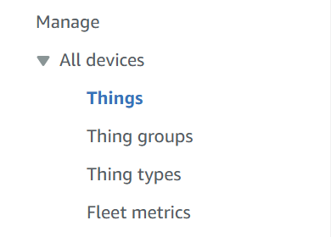

- After locating things to connect to the M5 stack we need to proceed to make a new thing to put as our "topic"
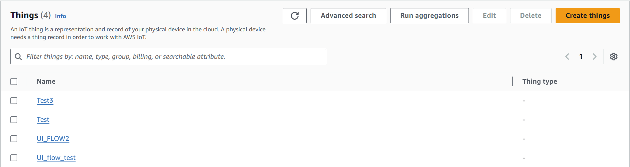
- Select "create thing" and proceed forward.

- In this case, we will be using "create single thing" for our project and then click "next"
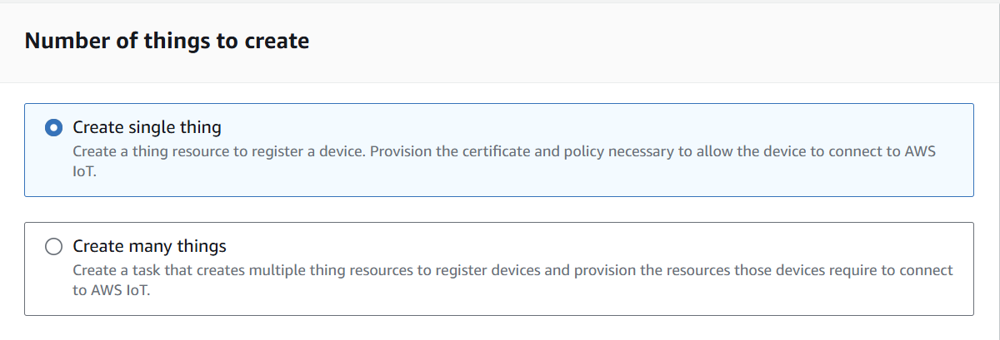

- Proceeding forward we will be naming out things, be mindful to keep it simple for easier configuring and fewer spelling mistakes in the long run. Enter "thing name" to name the object in my case I used "Test". We will leave the rest of the configurations as default. Then click “next”.
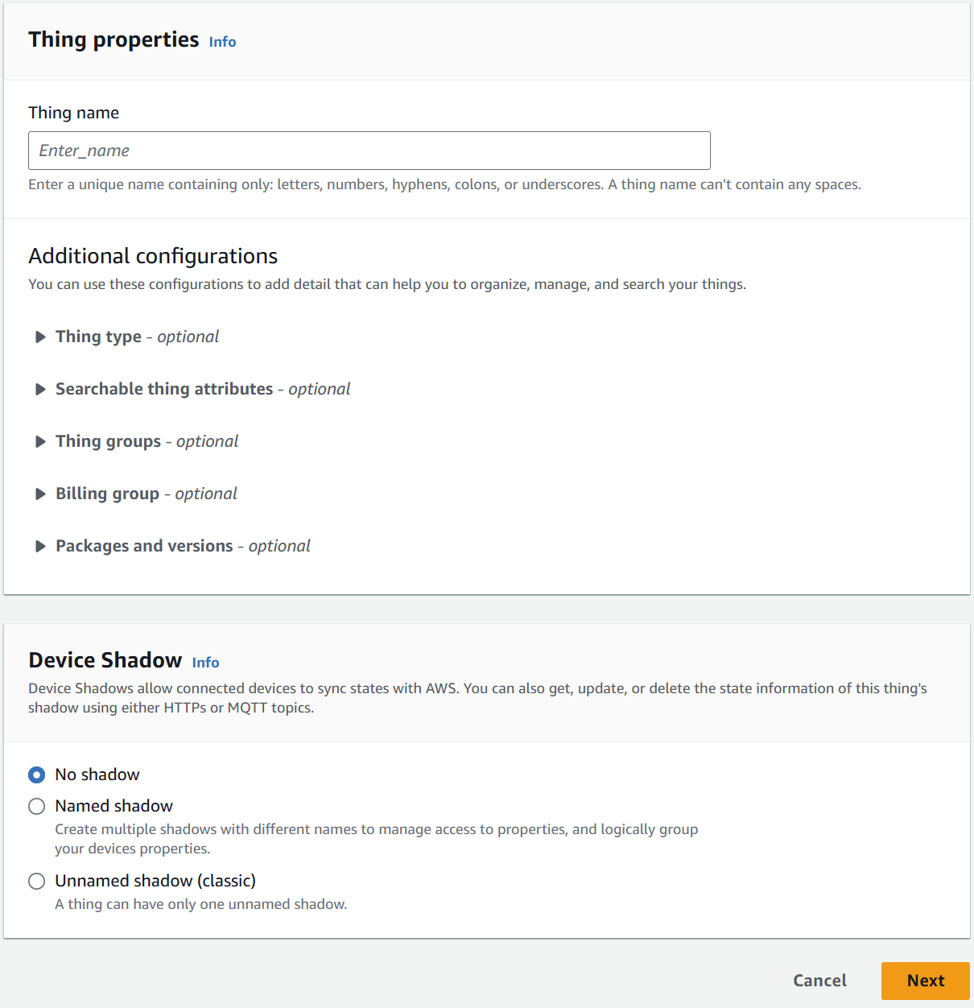

- Same as earlier we will be leaving this one in its default settings as we don't have any pre-downloaded certificates that we will need to use or regenerate. Once selected we will click "next".
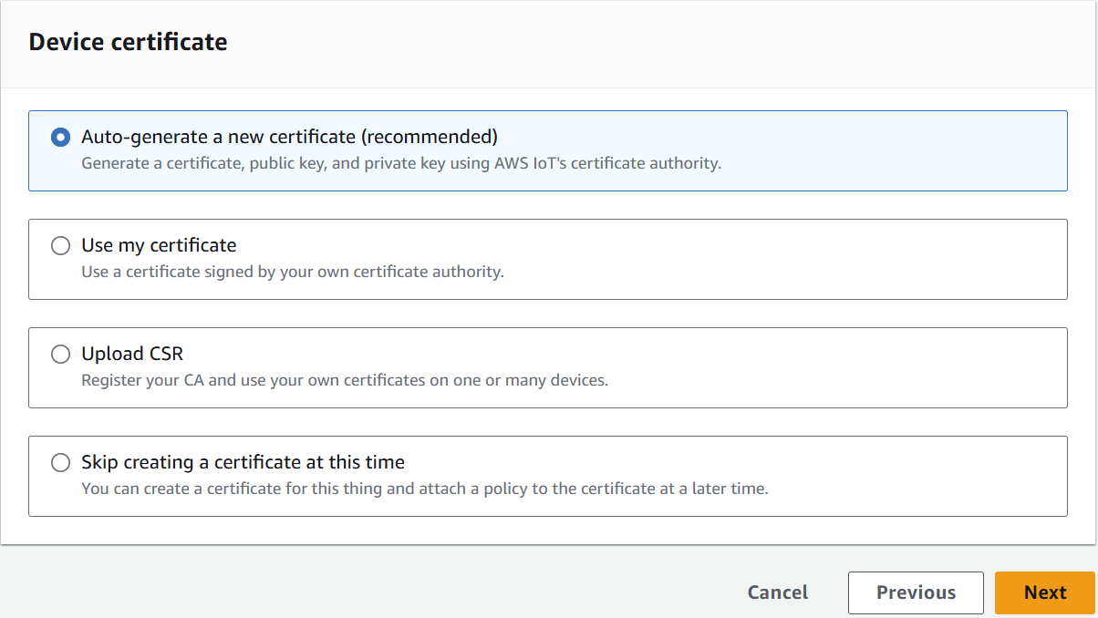

- Going on we will be attaching a policy to the thing this will allow our thing to have the permission to retrieve and send messages as well as who has access to the files.

- This is done by clicking on create policy in this case I used ( insert JSON code ). After which coming back to the page as shown below, I will choose the policy I made called "test" and then press "create thing"

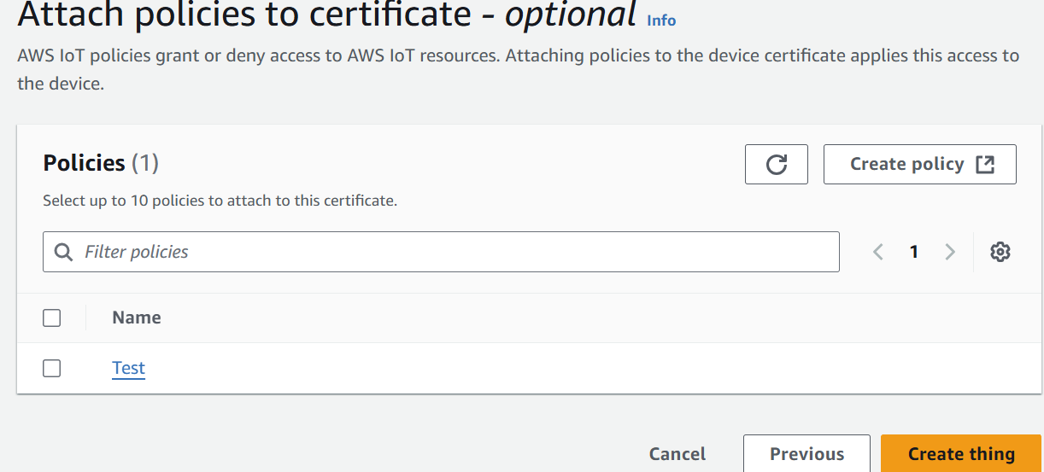

- A pop-up will come asking you to download certificates, download all the certificates and store them into a file on your personal device this is what we will be using to connect the AWS and IOT. The main files we will be using are the private key and the device certificate. For this configuration, we will also be using the root CA certificates.

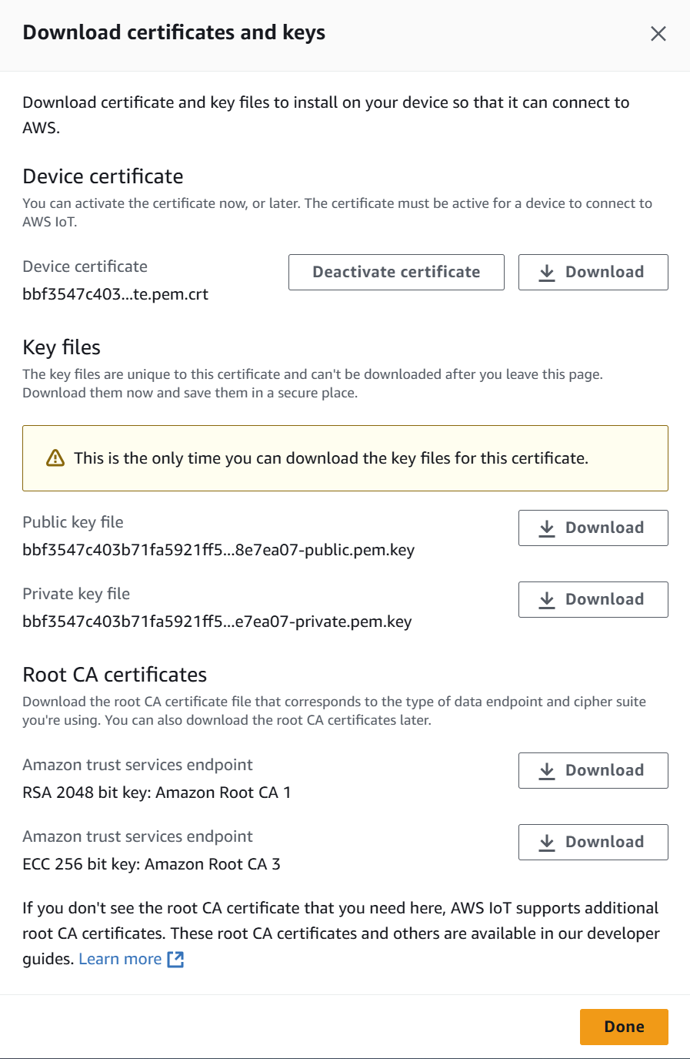

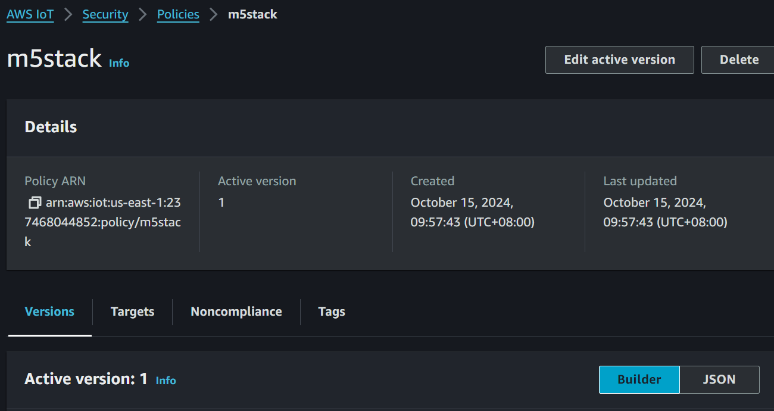

- Going back to our Blocky / Mircopython we will add the files into the code/ blocky. We will also name our “client_id" based on our thing name. While our topic name can be anything under the moon. In this scenario it is "UI_FLOW2". In the end, It should look something like the image below. 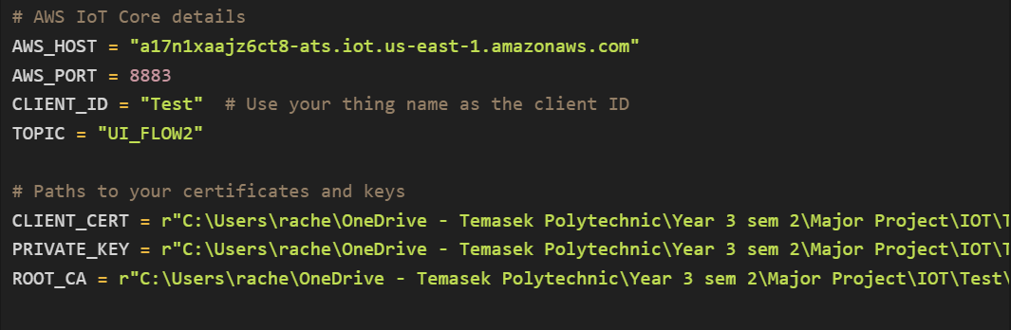
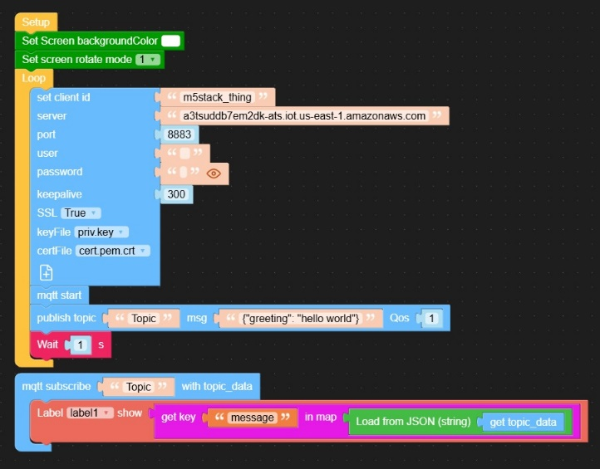

- To test the connection between the aws and the IoT we will be using the "MQTT test client". This can be found in the left nav bar under "test". Upon coming to this page we will be going forward with subscribing to the topic we allocated in the blocky/micro python. In this case, we will be using "UI_FLOW2" and then click "subscribe" 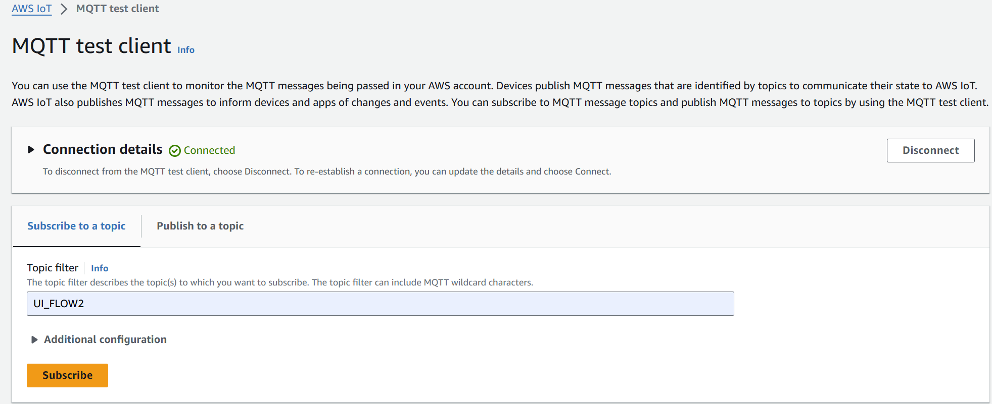

Click on “publish to a topic” to test the connection, this will allow us to see the timestamp and the connection of the AWS and IOT. This will also allow us to send messages to the IOT in the “topic name” put in our current topic name “UI_FLOW2” to send messages back into the IOT.

Challenges Encountered
- AWS IoT MQTT Connection Using SSL
Goal: Establish a secure SSL connection between the M5Stack Core2 and AWS IoT, read temperature and humidity data, and publish this data via MQTT.
Issue: During the setup of the SSL connection, the program encountered a "Value Error: invalid key" when trying to connect to AWS IoT over MQTT using SSL.
Root Cause: MicroPython’s MQTT module does not support SSL key and certificate handling the same way as standard Python. Our initial approach tried to use more advanced Python techniques that aren't compatible with MicroPython’s simplified handling of SSL.
- UIFlow Code Block to MicroPython Transition
Goal: Use UIFlow’s block-based programming environment to configure MQTT and AWS IoT connections, and then translate the block code into MicroPython to customize the logic further.
Issue: When transitioning from the UIFlow-generated blocks to MicroPython, we faced multiple syntax errors, especially in the way SSL certificates were being handled.
Root Cause: UIFlow’s block code generation doesn’t always translate well into MicroPython when dealing with more complex features like certificate management. The file paths and structures weren’t adapted correctly for MicroPython’s requirements, causing errors.
- Incorrect SSL Certificate File Paths
Goal: Load SSL certificates and keys correctly from the M5Stack Core2's file system to establish a secure connection with AWS IoT Core.
Issue: The program threw FileNotFoundError and "invalid key" errors when trying to access the SSL certificates from paths such as /flash/res/priv.key.
Root Cause: The certificate files weren't properly transferred to the M5Stack's internal storage. The /flash directory, which was expected to contain the files, wasn’t mapped to external storage (like OneDrive) correctly, so the device couldn’t find the required SSL files.

- SSL Certificate and Socket Wrapping with us.wrap_socket
Goal: Wrap the network socket in SSL to secure the MQTT communication.
Issue: We encountered syntax errors when trying to wrap the socket using ussl.wrap_socket, particularly due to the improper handling of the certificates and key files.
Root Cause: MicroPython’s ussl module has limited support for certificates and key files compared to regular Python. We were trying to pass SSL certificates in a way that wasn't compatible with MicroPython’s simpler SSL implementation.

- Connection to AWS IoT Core Using umqtt.simple
Goal: Establish a secure connection to AWS IoT Core using the umqtt.simple module, and publish the temperature and humidity data collected from the sensors.
Issue: The connection attempts to AWS IoT Core failed due to issues with SSL certificates and incorrect syntax in the MQTT setup.
Root Cause: The umqtt.simple module in MicroPython has limitations when handling SSL connections, and our setup didn’t account for these constraints. Additionally, incorrect file paths for the SSL certificates prevented the connection from being successfully established.
- Reading Certificates from Local Storage
Goal: Properly load SSL certificates from the M5Stack Core2's local storage to support the secure connection.
Issue: There were errors in accessing the certificate files due to the program pointing to incorrect file paths.
Root Cause: The file paths used in the code didn't align with the M5Stack Core2's internal storage structure. As a result, the program couldn't locate the required SSL files, which caused the SSL connection to fail.
- Continuous Connection Loop Development
Goal: Create a stable connection loop that continuously reads sensor data and publishes it to AWS IoT Core in real-time.
Issue: Syntax errors occurred during the initialization of the MQTT client and while wrapping the socket with SSL in a continuous loop.
Root Cause: Our approach mixed unsupported parameters and functions when setting up SSL and MQTT, leading to persistent connection loop errors.

Successful AWS code for Micro Python
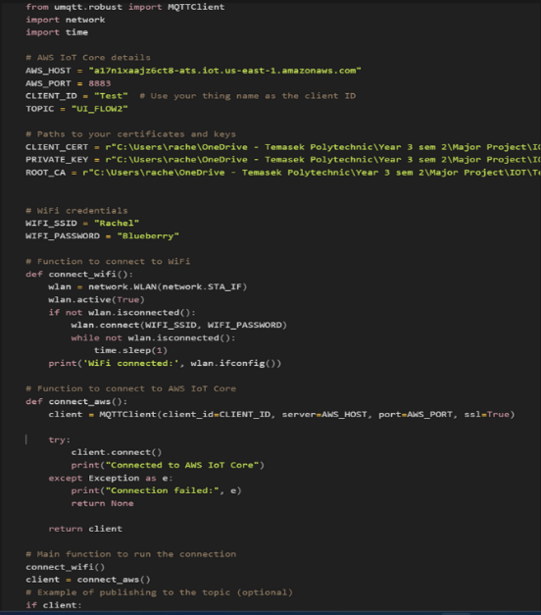
- What Worked or Partially Worked
- Wi-Fi Connection
Goal: Connect the M5Stack Core2 to the local Wi-Fi network.
Success: The M5Stack successfully connected to the Wi-Fi using the provided SSID and password.
Why It Worked: The network.WLAN module in MicroPython is reliable and the connection logic was implemented correctly. A loop was set up to wait until the Wi-Fi connection was established before moving on to other tasks.
- Basic LCD Display
Goal: Display temperature and humidity data on the M5Stack Core2's LCD screen.
Success: The screen was initialised and updated with sensor data as expected.
Why It Worked: The M5Stack libraries, such as m5stack and m5stack_ui, were used properly to control the LCD. The screen was configured correctly to display messages and sensor readings.
- Reading Sensor Data (Analog Sensors)
Goal: Read temperature and humidity data from the analogue sensors connected to the M5Stack Core2.
Success: The sensors provided valid readings, which were processed into meaningful temperature and humidity values.
Why It Worked: The ADC (Analog-to-Digital Converter) was correctly initialized with appropriate settings. Scaling functions were applied to convert the raw data into usable values.
- File Loading Logic for SSL Certificates
Goal: Read SSL certificates and keys from the file system to set up secure MQTT communication.
Partial Success: The function for loading certificates worked, assuming the file paths were correct.
Why It Worked: The open() function for reading files was properly implemented, with adequate error handling for missing files.
- Basic MQTT without SSL
Goal: Use the umqtt.simple module to publish data to an MQTT broker without SSL.
Partial Success: Although the AWS IoT connection using SSL wasn't successful, basic MQTT publishing worked on simpler servers that didn't require SSL.
Why It Worked: The MQTT client setup, subscribing to topics, and publishing data were handled correctly, without the added complexity of SSL.
- Connection to AWS IoT Core Using umqtt.simple
Goal: Establish a secure connection to AWS IoT Core using the umqtt.simple module, and publish the temperature and humidity data collected from the sensors.
Issue: The connection attempts to AWS IoT Core failed due to issues with SSL certificates and incorrect syntax in the MQTT setup.
Root Cause: The umqtt.simple module in MicroPython has limitations when handling SSL connections, and our setup didn’t account for these constraints. Additionally, incorrect file paths for the SSL certificates prevented the connection from being successfully established.
- Reading Certificates from Local Storage
Goal: Properly load SSL certificates from the M5Stack Core2's local storage to support the secure connection.
Issue: There were errors in accessing the certificate files due to the program pointing to incorrect file paths.
Root Cause: The file paths used in the code didn't align with the M5Stack Core2’s internal storage structure. As a result, the program couldn’t locate the required SSL files, which caused the SSL connection to fail.
- Continuous Connection Loop Development
Goal: Create a stable connection loop that continuously reads sensor data and publishes it to AWS IoT Core in real time.
Issue: Syntax errors occurred during the initialization of the MQTT client and while wrapping the socket with SSL in a continuous loop.
Root Cause: Our approach mixed unsupported parameters and functions when setting up SSL and MQTT, which led to persistent errors in the connection loop.

- Tackling the issues
- Simplified SSL Handling: Micro Python's ussl module requires a more simplified approach to SSL, where certificates cannot be handled the same way as in standard Python. Future attempts should avoid passing file paths directly and explore alternatives for secure communication.
- Sensor Not Responding: Verified sensor compatibility with the M5Stack Core2.7. Checked if the sensor requires specific initialization commands as per the sensor’s datasheet.
- Micro Python’s Limitations with AWS IoT: The umqtt.simple module in Micro Python has certain limitations when it comes to SSL connections, particularly for complex setups like AWS IoT Core. We need to adapt our approach to work within these constraints or consider alternatives.
- File Path Management: The handling of certificates and key file paths is crucial. Certificates need to be correctly transferred and stored on the M5Stack's internal flash memory to ensure they can be accessed without errors.
- Wi-Fi Stability: The Wi-Fi connection remained stable throughout testing, but more work is needed on the SSL and MQTT side to achieve full functionality with AWS IoT.

- Working configurations with Blocky
Using Blocky we tried a second round of integration comparing which was optimal for AWS integration.
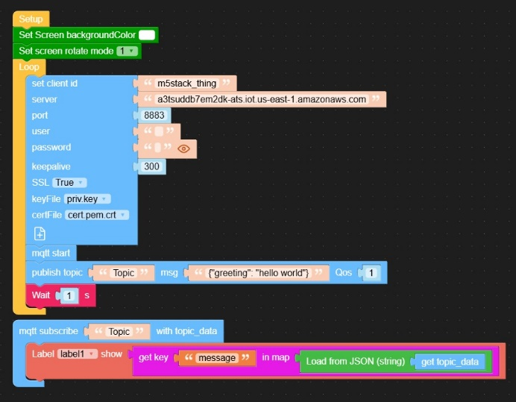

- Visual Screen
Set Screen Background Colour and Set Screen Rotate Mode:
  - The blocks are set up for display onto the M5 stack Core 2 device allowing the colour to be set to white and allowing it so that everything is upright
- Connection Setup
MQTT Connection Settings:
  - Client ID: a unique name for your device (in this case, it’s "m5stack_thing"), which AWS IoT uses to recognize the device.
  - Server: The URL of the AWS IoT server. This is the “address” your device connects to for sending and receiving data.
  - Port: The port number is 8883, which is specifically for secure MQTT connections.
  - SSL: SSL (Secure Sockets Layer) is enabled, meaning your data is encrypted during transmission for added security.
  - Key File and Cert File: These files (your private key and certificate) authenticate your device with AWS IoT, confirming that it’s allowed to connect.
MQTT Start:
  - This block starts the MQTT connection allowing the device to communicate with AWS IoT.
- Publishing Data
Publish Topic:
  - This block sends data to AWS IoT. It:
    - Topic: Think of a topic as a “channel” that your device can send or listen to messages on. You’re choosing to publish on a topic called "Topic".
    - Message: The message being sent here is {"greeting": "hello world"}, which is in JSON format.
    - QoS (Quality of Service): Setting QoS to 1 ensures that AWS IoT will receive the message.
- Receiving Data
MQTT Subscribe:
  - This block tells the device to “listen” for any messages sent to the "Topic" channel.
Label Display:
  - When a message is received, this block extracts specific information and displays it:
    - Load from JSON: This block reads the incoming message (stored as topic_data) in JSON format.
    - Get Key: It looks for a specific key within the JSON data, here "message".
    - Show on Label: The value of "message" is then displayed on the device’s screen in label1.
- IoT and M5 stack core 2 Troubles
- Device blackouts: The device blacked out several times due to pre-existing Wi-Fi settings, which caused issues. We needed to bypass the current Wi-Fi configuration and reboot the machine. This was resolved with the help of M5Stack documentation and AWS resources.
- Burner connection issues: Outdated ports and missing software made connecting to the M5Burner difficult. We experimented with different ports and drivers before identifying the optimal setup for our needs.
- Testing across multiple laptops: To overcome port issues, we tried configuring two different laptops. After multiple adjustments, including changes to burner settings, USB configurations, and Wi-Fi/passwords, one of the laptops was found to be compatible with the M5Stack.
- Limited documentation for UIFlow 2.0: The lack of comprehensive documentation and video resources for UIFlow 2.0 caused some confusion. We addressed this by researching older versions of the software and piecing together the relevant information.
- No Data Displayed:
  - Verified the physical connections between the Earth Monitor sensor and Port B.
  - Ensured SENSOR_PIN was correctly set to GPIO39, which was appropriate for analogue input.

AWS Pipeline
Establishing the AWS pipeline:
For the AWS pipeline, there were a couple of thought processes that were looked into while there were a few options that we considered to be our final pipeline before settling for the final result

Options:
- Amazon iot core – AWS lambda – s3 bucket – AWS glue – Amazon API gateway – amazon sagemaker – power bi
- Amazon iot core – Amazon S3 – AWS lambda – AWS Athena – AWS glue – AWS sqs – Amazon Cloudwatch – AWS cloud trail – power bi
- Amazon iot core – amazon s3 – AWS lambda – amazon s3 – AWS glue – AWS Athena – AWS step function – AWS event bridge – AWS cloud watch – power bi

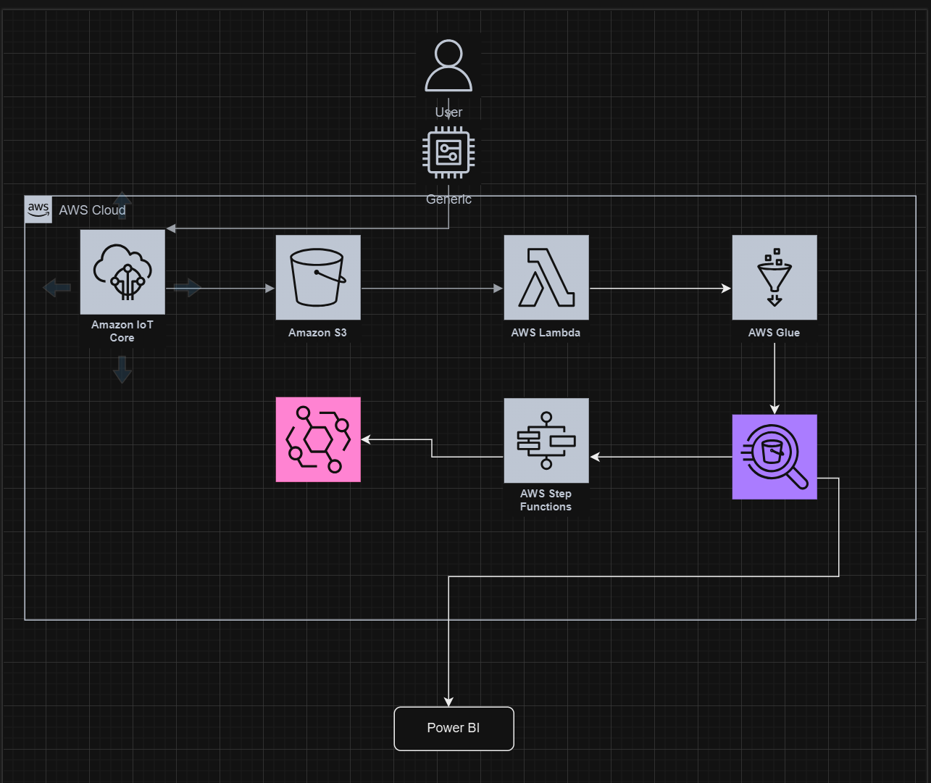

The final choice is Option 3, which is further explained below:

Amazon IoT Core
Technical Advantage:
IoT Core's support for MQTT ensures lightweight, low-latency data communication, ideal for low-power IoT devices like the M5Stack Core2. Its scalability and secure connectivity safeguard data integrity and prevent unauthorized access, ensuring reliable operation even as device volumes grow.
Business Value:
The real-time data collection capabilities of IoT Core enable prompt responses to environmental changes, essential for maintaining optimal plant growth conditions. This reduces manual monitoring efforts, optimizes operational efficiency, and enhances the value of your vertical gardening solution by fostering sustainability and productivity.

Amazon S3
Technical Advantage:
With its highly durable, cost-effective storage, S3 can manage large datasets, including raw, processed, or fully analyzed data. Its seamless integration with AWS services simplifies data retrieval, enabling efficient workflows across the pipeline.
Business Value:
S3's ability to store historical data supports trend analysis, empowering better resource management for plant growth optimization. This long-term insight fosters efficient operations and sustainable practices, reinforcing the project's contribution to a greener future.

AWS Lambda
Technical Advantage:
Lambda's serverless architecture eliminates the need for dedicated infrastructure, scaling automatically with workload demands. This results in flexible, cost-effective data processing, allowing on-demand functionality without unnecessary overhead.
Business Value:
Event-driven data processing accelerates preparation for analysis, reducing latency and improving the accuracy of insights. Lambda lowers operational costs while enabling timely decision-making, essential for maintaining ideal environmental conditions for plant species.

AWS Athena
Technical Advantage:
Athena supports ad hoc analysis of structured formats like Parquet and CSV. Its infrastructure-free model reduces complexity and empowers quick insights with minimal setup.
Business Value:
Athena democratizes data access, enabling non-technical users to perform queries and derive insights quickly. This supports data-driven strategies, optimizing resource use and ensuring informed decision-making for operational improvements.

AWS Glue
Technical Advantage:
Glue simplifies data transformation and schema discovery, reducing manual efforts in data preparation. Its integration with Athena and other AWS tools ensures streamlined workflows within the pipeline.
Business Value:
Automated ETL processes accelerate time-to-insight, allowing your team to focus on analysis rather than data wrangling. Clean, reliable data enhances decision-making accuracy, driving operational and environmental efficiencies.

Amazon EventBridge
Technical Advantage:
EventBridge's precise event routing supports efficient automation across AWS services. Its serverless architecture enables seamless event-driven communication, reducing complexity and enhancing responsiveness.
Business Value:
By automating workflows, EventBridge eliminates manual intervention, saving time and improving operational agility. Its real-time event handling ensures the timely execution of tasks, optimizing your project's performance and service delivery.

AWS Step Functions
Technical Advantage:
Step Functions provide a visual workflow editor with built-in retries and error handling, ensuring reliable execution of multi-step processes. They support parallelization for enhanced efficiency and scalability.
Business Value:
Step Functions streamline operations, reducing the likelihood of errors and delays in task execution. By automating and managing workflows, they improve productivity, reduce costs, and ensure timely delivery of actionable insights.

Amazon CloudWatch
Technical Advantage:
Real-time dashboards and alerts enable proactive issue detection and resolution. CloudWatch integrates with other AWS services to provide end-to-end observability, enhancing system dependability.
Business Value:
Proactive monitoring minimizes downtime and optimizes pipeline performance. CloudWatch ensures uninterrupted service, reducing costs and maintaining user satisfaction, which is critical for sustaining project success.

Analysis Tools: Looker, Power BI, Tableau
Technical Advantage:
Their robust visualization features simplify complex data interpretation, offering real-time insights from AWS-integrated datasets. These tools cater to diverse user needs, from advanced analytics to intuitive dashboards.
Business Value:
Effective data visualization empowers stakeholders to make informed, strategic decisions quickly. These insights drive improvements in operational efficiency and sustainability, maximizing the project's impact across technical and business domains.

Instructions: Connecting AWS IoT Core to AWS S3

Create an S3 Bucket
- Log in to the AWS Management Console and navigate to the S3 service.
- Create a new bucket and name it uiflow.
- Adjust public access settings:
  - Untick the checkbox labeled "Block all public access" to simplify editing.
  - Configure measures to ensure the public has limited access to the bucket and objects within.
- Disable ACLs: In the bucket settings, ensure ACLs are disabled for the bucket.

Configure CORS Settings
- In the Permissions tab of your S3 bucket, locate the CORS configuration section.
- Replace the default configuration with the following:
[
{
"AllowedHeaders": [
"Authorization"
],
"AllowedMethods": [
"GET"
],
"AllowedOrigins": [
"*"
],
"ExposeHeaders": [],
"MaxAgeSeconds": 3000
}
]

Set the Bucket Policy
- Navigate to the Permissions tab and select Bucket Policy.
- Through trial and error, finalize the following bucket policy to allow necessary operations:
{
"Version": "2012-10-17",
"Id": "UpdatedPolicy",
"Statement": [
{
"Sid": "PublicReadPutObject",
"Effect": "Allow",
"Principal": "*",
"Action": "s3:PutObject",
"Resource": "arn:aws:s3:::uiflow/*",
"Condition": {
"Null": {
"s3:x-amz-server-side-encryption-aws-kms-key-id": "true"
}
}
},
{
"Sid": "PublicReadGetObject",
"Effect": "Allow",
"Principal": "*",
"Action": "s3:GetObject",
"Resource": "arn:aws:s3:::uiflow/*"
}
]
}
- Save the policy and verify its functionality.

Configure AWS IoT Core
- Create a new Thing:
  - In AWS IoT Core, create a new "Thing" to represent your IoT device.
  - Attach appropriate policies to the Thing for data transmission.
- Set up an IoT policy:
  - Create a policy that allows data to be sent from the IoT device to AWS services.
- Create a rule:
  - Navigate to the Rules section in AWS IoT Core.
  - Create a new rule that triggers data to be sent to the S3 bucket (uiflow) whenever data is published to a specific topic.

Test the Connection
- Publish test data to the configured IoT topic to ensure it is successfully transferred to the S3 bucket.
- Verify the data in uiflow to confirm the setup works as expected.

Connection of the S3 Bucket to AWS Lambda to S3 bucket

Step 1: Prepare the S3 Bucket
- Connect your IoT Core to the S3 Bucket: Ensure that your IoT Core publishes data to your initial S3 bucket. This is the source bucket where IoT data will be stored.
- Make the Bucket Public:
  - Go to S3 in the AWS Console, select your source bucket, and adjust the Permissions to make it public.
  - Update the Bucket Policy as shown in later steps to ensure Lambda has the required access.
- Making of public bucket:
  - S3 console select Create a bucket
  - Upon selection, we will make the following configurations
    - We will choose ACLs enabled for the bucket of choice, this is so that we can make our bucket public.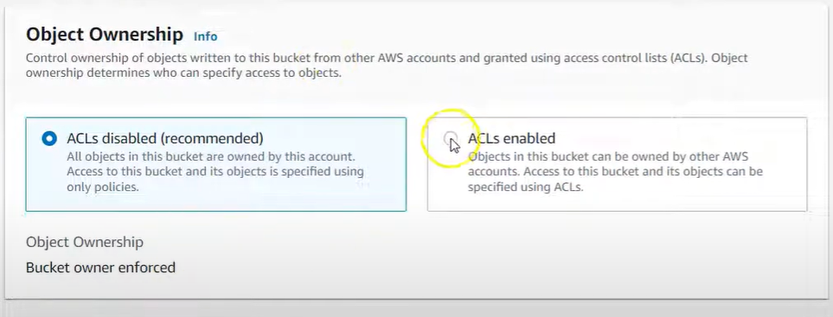
    - We will also change the settings from non-public access to public access by checking off the "Block all public access" 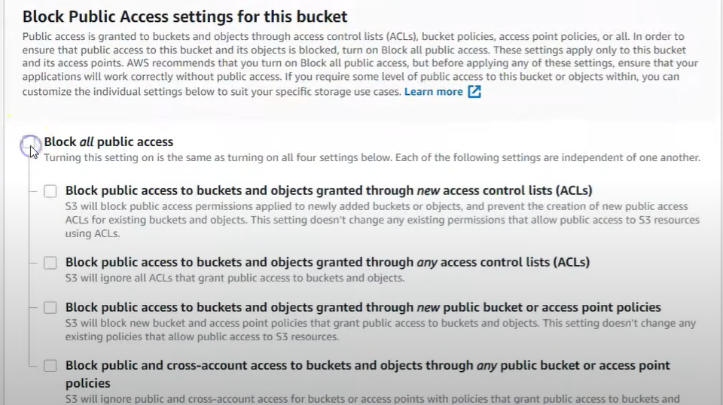
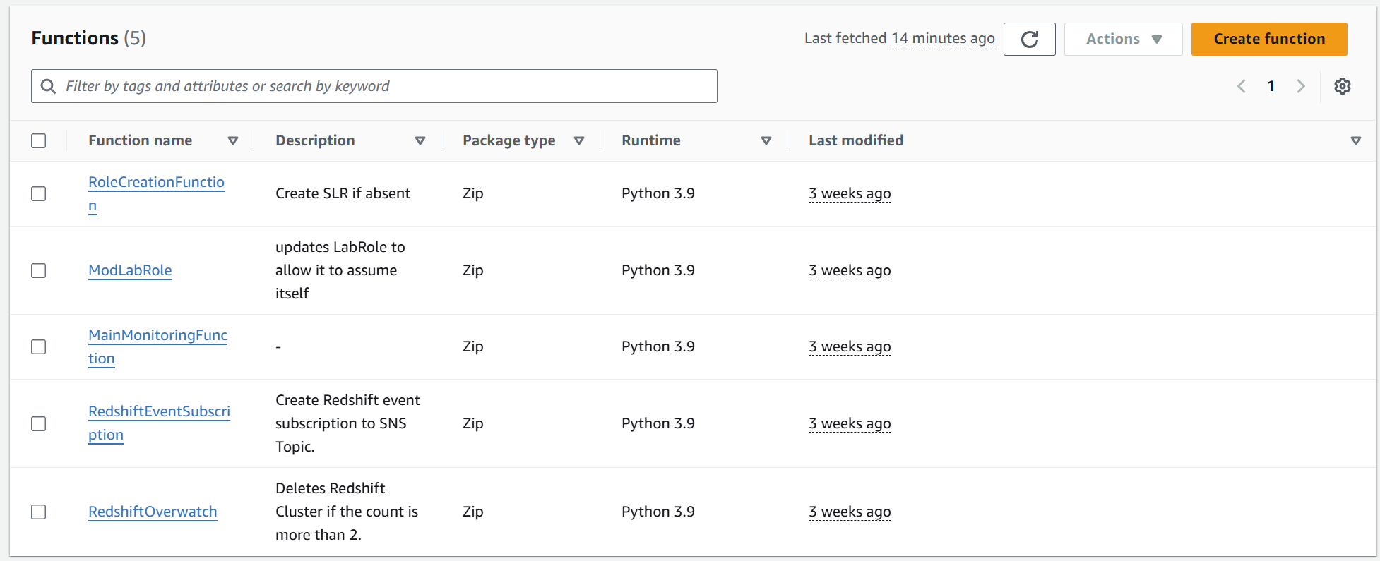

Step 2: Set Up a New Lambda Function
- Navigate to AWS Lambda:
  - Open AWS Lambda in the AWS Console.
  - In the left sidebar, select Functions.
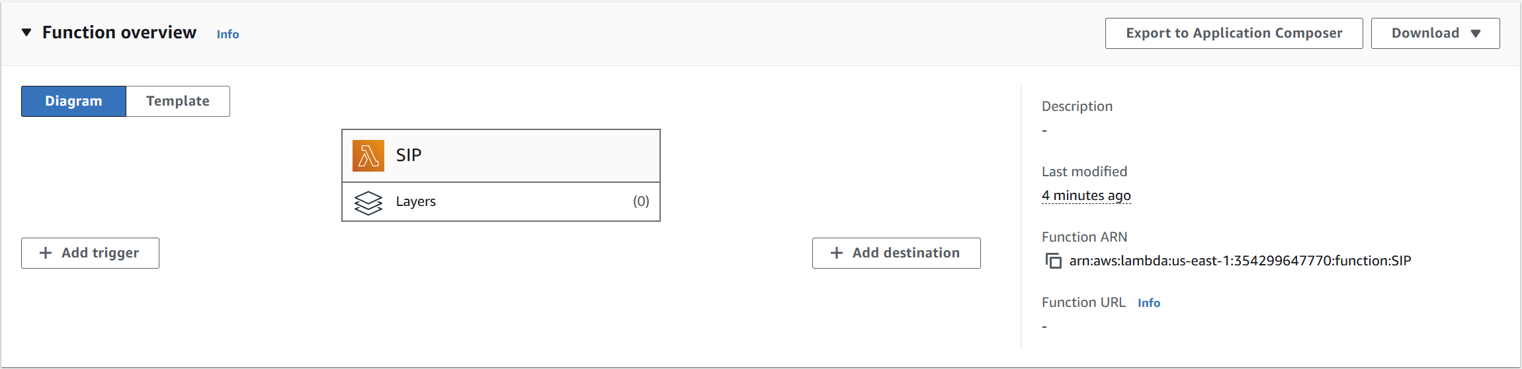
- Create the Function:
  - Click on the Create function.
  - Choose an Author from scratch.
  - In the Function name, enter a name like "SIP" to identify your Lambda function.
  - Set the Runtime to Python 3.8 (or another compatible version with your libraries).
  - Choose x86_64 for Architecture unless you have specific reasons to use an ARM-based instance.
  - For the Execution role, select Use an existing role and attach the role that grants necessary permissions for S3 access.
  - Click the Create function.

Step 3: Add AWS SDK Layers for Data Handling in Lambda
To allow Lambda to process and manipulate data from S3, you need to add the necessary layers:
- Go to the Layers Section:
  - In your Lambda function's configuration page, select Layers.
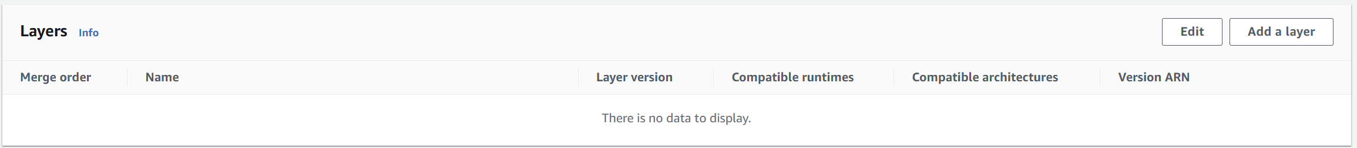
  - Click on Add a layer to configure layers.

- Add the First Layer – AWS SDK Pandas:
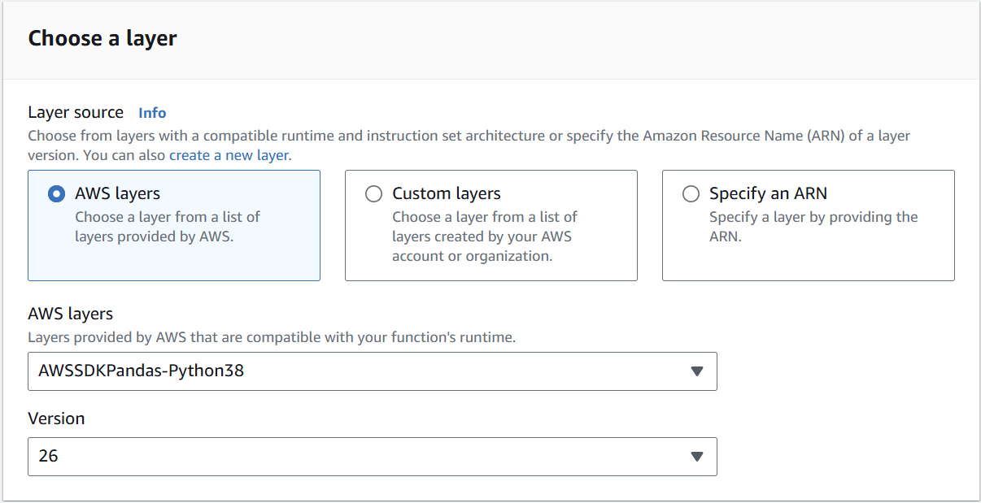
  - Select AWS layers from the available options.
  - From the list, choose AWSSDKPandas-Python38 and set Version to 26. This SDK provides tools to easily read from and write to S3.

- Add the Second Layer – AWS Wrangler:
  - To use AWS Wrangler, a data wrangling library, you first need to install it in Jupyter Notebook.
    - In Jupyter Notebook, run: pip install awswrangler.
    - After installation, locate the awswrangler files in Anaconda under lib/site-packages.
  - Zip the awswrangler package files for upload.
  - In Lambda, go back to Layers and create a new custom layer.
  - Name this layer and set the Runtime to Python 3.8.
  - Upload the zipped awswrangler package to this layer.

Step 4: Implement a Test Event to Simulate S3 Trigger
To test Lambda’s ability to receive events when new objects are uploaded to S3:
- Go to Code Source:
  - In the Lambda function's Code source section, select Test.
- Configure the Test Event:
  - Choose Configure test event and add the following JSON to simulate an S3 event:
json
Copy code
{
"Records": [
{
"eventVersion": "2.1",
"eventSource": "aws:s3",
"awsRegion": "us-east-1",
"eventTime": "2024-11-05T05:15:57.875Z",
"eventName": "ObjectCreated:Put",
"s3": {
"bucket": { "name": "tbucket0309" },
"object": { "key": "myKey", "size": 59 }
}
}
]
}
- Save and Deploy the Test:
  - Save this test configuration and deploy it to verify the function is triggered correctly when a new file is uploaded to the specified S3 bucket.

Step 5: Add Lambda Code to Handle S3 Bucket Data
This code enables your Lambda function to read from the source S3 bucket, process the data, and write to a destination S3 bucket.
- Add the following Python Code to Lambda:
Python
Copy code
import awswrangler as wr
import os
import logging
import boto3

logger = logging.getLogger()
logger.setLevel(logging.INFO)

s3_client = boto3.client('s3')

def lambda_handler(event, context):
logger.info("New files uploaded to the source bucket.")
logger.info(f"Event received: {event}")

Try:
# Define file names and buckets
key = "iot_generated_data2.csv" # Update this to match the file name
source_bucket = "uiflowbucket" # Set the source bucket name
destination_bucket = os.environ['DESTINATION_BUCKET'] # Define destination bucket as an environment variable

source_path = f"s3://{source_bucket}/{key}"
destination_path = f"s3://{destination_bucket}/{key.replace('.csv', '_wrangled.csv')}"

# Check if the file exists
try:
s3_client.head_object(Bucket=source_bucket, Key=key)
logger.info(f"File found: {source_path}")
except s3_client.exceptions.NoSuchKey:
logger.error(f"No file found at path: {source_path}")
return {"errorMessage": f"No files found at: {source_path}.", "errorType": "NoFilesFound"}

# Read data from S3
data = wr.s3.read_csv(path=source_path)
logger.info(f"Data loaded. Shape: {data.shape}")
logger.info(f"Data preview:\n{data.head()}")

# Wrangle data
if data.empty:
logger.warning("DataFrame is empty.")
return {"errorMessage": "DataFrame is empty after loading CSV.", "errorType": "EmptyDataFrame"}
data = data.fillna("N/A")

# Write processed data to destination
wr.s3.to_csv(df=data, path=destination_path, index=False)
logger.info(f"File successfully written to {destination_path}")
return {"status": "success", "message": f"File written to {destination_path}"}

except Exception as error:
logger.error("Error in Lambda processing.")
raise error
- Save and Deploy the Code.

Step 6: Update S3 Bucket Policies and CORS
To ensure that Lambda has the necessary permissions to read and write to the S3 buckets:
- Modify the Bucket Policy for uiflowbucket:
  - Go to the Permissions tab of uiflowbucket and add the following policy:
json
Copy code
{
"Version": "2012-10-17",
"Statement": [
{
"Effect": "Allow",
"Principal": "*",
"Action": "s3:PutObject",
"Resource": "arn:aws:s3:::uiflowbucket/*",
"Condition": {
"Null": { "s3:x-amz-server-side-encryption-aws-kms-key-id": "true" }
}
},
{
"Effect": "Allow",
"Principal": "*",
"Action": "s3:GetObject",
"Resource": "arn:aws:s3:::uiflowbucket/*"
}
]
}
- Set up CORS Configuration:
  - Under Permissions in the CORS configuration, add:
json
Copy code
[
{
"AllowedHeaders": [ "Authorization" ],
"AllowedMethods": [ "GET" ],
"AllowedOrigins": [ "*" ],
"MaxAgeSeconds": 3000
}
]

Step 7: Test the Entire Workflow
- Trigger a Test Event: Upload a sample file (matching the specified name and format) to uiflowbucket and check that it is processed and moved to finalbucket311204 as specified in your Lambda function.

Challenges Established
  - Different Bucket Configurations:
We initially experimented with bucket settings, including private and public configurations, to verify that the Lambda function could read from and write to both source and destination buckets. We tried several policy adjustments to allow cross-account permissions and accommodate multiple access levels.
Outcome: This approach did not work as expected, as the IAM role policies were too restrictive for the Lambda function to gain access. Attempting to adjust these further was not feasible due to account-level limitations.
  - Policy Code Adjustments:
We modified bucket policy codes to include broader permissions for specific actions like s3:PutObject, s3:GetObject, and s3:ListBucket. This was intended to create permissions for both public and private access for different user groups, but restrictions on IAM roles and budget constraints prevented further changes.
Outcome: Although some permissions were successfully added, the adjustments did not allow the function to run consistently as intended, and certain group permissions could not be applied across all actions needed.
- Code Approaches and Transformations Tried:
Several code variations were attempted, each aimed at handling JSON data through the Lambda function and saving it in the second S3 bucket. For instance, we tried:
    - First Code Block: This code loads JSON data from an S3 object into a Python dictionary, processes it, and saves it back to the destination bucket. It also checks whether the data is a single JSON object or a list and then writes it as JSON using awswrangler.
    - Second Code Block: In this version, the function reads JSON data from the source S3 bucket, processes it into a DataFrame if necessary, and writes it to the target bucket in JSON format.
Outcome: These codes didn’t execute as expected, primarily due to the inability to accurately configure all necessary permissions. Budget limitations and restrictions on adjusting key IAM roles further hindered these attempts.

Establishing a Connection from S3 to Athena
- Deploy and Test Lambda Data Transfer: Deploy the Lambda function and let it run. Verify that the data is successfully transferred from the source bucket to the destination bucket.
- Access Athena and Prepare for Crawling: Open Athena in the AWS Management Console. In the Athena editor, scroll down and select the option to create an AWS Glue Crawler, which will structure your data.
- Set Crawler Properties: In the “Set Crawler Properties” page, provide a descriptive name and optional description for your crawler. Click Next to proceed.
- Choose Data Sources and Classifiers: On the "Choose Data Sources and Classifiers" page, select Data Sources and then Add a Data Source.
- Select S3 as the Data Source: Choose S3 as the data source type. In the "S3 Path" field, select the S3 bucket that contains the data you transferred. Leave the other settings as default and click Add an S3 data source.
- Create a Database for Crawler: The setup will prompt you to select or create a database for storing metadata. Choose Create a New Database and provide a name that suits your data.
- Select Database in Glue Crawler
- Refresh and Select: Return to the Glue Crawler setup and refresh the page if needed. Then, select the database you just created.
  - Finalize and Run the Crawler:
  - Complete Setup: Click Next and then Create Crawler to finalize the setup.
  - Run Crawler: Once the crawler is created, select it from your list and click Run Crawler. This process may take some time as it scans the data and creates tables.
  - Access Data in Athena: After the crawler completes, go back to Athena. In Athena, select the database created by the Glue Crawler from the Database dropdown. You should see the data tables available under Tables.
  - Validate Data Format with Queries

Establishing a connection from AWS Athena to the Step function
- Set Up IAM Role for Step Functions:
  - Create or update an IAM role (e.g., labrole) for Step Functions with the following permissions:
    - Invoke Lambda functions.
    - Start and manage Glue crawlers.
    - Read/write access to S3 buckets as required.
    - Query access for Athena.
Example policy snippet for labrole:
json
Copy code
{
"Version": "2012-10-17",
"Statement": [
{
"Effect": "Allow",
"Action": [
"lambda:InvokeFunction",
"glue:StartCrawler",
"s3:ListBucket",
"s3:GetObject",
"athena:StartQueryExecution"
],
"Resource": "*"
}
]
}
- Configure Lambda Function for Glue Crawler:
  - Write a Lambda function that starts the Glue crawler. Use AWS SDK for Python (Boto3) for the implementation.
  - Include error handling for scenarios like a running crawler or unexpected failures.
Example Lambda function code:
Python
Copy code
import boto3

def lambda_handler(event, context):
glue_client = boto3.client('glue')
crawler_name = event['CrawlerName']
Try:
response = glue_client.start_crawler(Name=crawler_name)
print("Glue crawler started:", response)
except glue_client.exceptions.CrawlerRunningException:
print("Crawler is already running.")
except Exception as e:
print("Error starting crawler:", str(e))
- Define Step Functions Workflow:
  - Use Step Functions to orchestrate the tasks, ensuring sequential control and error handling.
  - Add a task state for invoking the Lambda function to start the Glue crawler.
  - Ensure the state includes parameters to specify the crawler name.
Example state definition in Step Functions:
json
Copy code
"RunGlueCrawler": {
"Type": "Task",
"Resource": "arn:aws:lambda:<region>:<account-id>:function:YourGlueLambdaFunction",
"Parameters": {
"CrawlerName": "iot3 db"
},
"Next": "QueryWithAthena"
}
- Test and Deploy:
  - Test the Step Functions workflow by triggering it and validating each task's execution.
  - Ensure IAM roles and Lambda functions are functioning correctly with appropriate logs.

Step Function Implementation
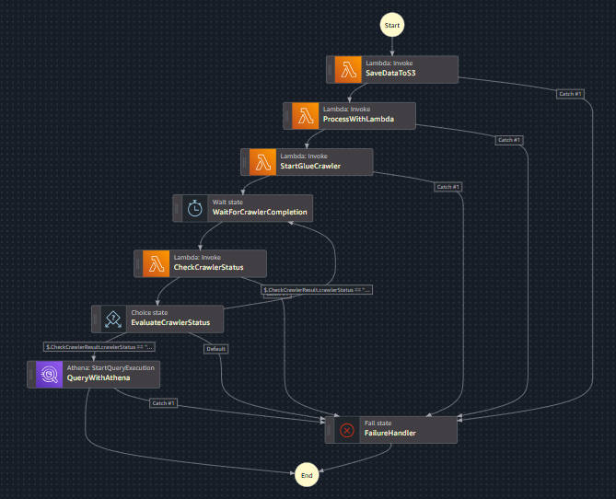

Steps to Create a Step Function
- Access AWS Step Functions:
  - Log in to the AWS Management Console and navigate to Step Functions.
  - On the left-hand menu, click the hamburger icon and select State machines.
- Create a State Machine:
  - Click Create state machine.
  - Choose the option to create a new state machine to automate the pipeline.
- Define the State Machine Workflow:
  - Use the code editor to define the pipeline workflow.
  - Break down each function into tasks according to the project pipeline.

Workflow Explanation with Code Snippets
The IoT data processing pipeline leverages AWS Step Functions to orchestrate multiple AWS services for data storage, processing, and querying. Below is an in-depth explanation of each step, supported by relevant code snippets.

- Save IoT Data to S3
Purpose:
This step saves IoT-generated data, received as JSON input, into an Amazon S3 bucket for subsequent processing. The S3 bucket serves as the pipeline's starting point for data ingestion.
Code Snippet:
"SaveDataToS3": {
"Type": "Task",
"Resource": "arn:aws:lambda:us-east-1:354299647770:function:SIP",
"Parameters": {
"Bucket": "uiflowbucket",
"Key": "iot_generated_data2.csv",
"Body.$": "$.Body"
},
"Retry": [
{
"ErrorEquals": ["States.ALL"],
"IntervalSeconds": 5,
"MaxAttempts": 3,
"BackoffRate": 2
}
],
"Catch": [
{
"ErrorEquals": ["States.ALL"],
"Next": "FailureHandler"
}
],
"Next": "ProcessWithLambda"
}
Explanation:
- Task Type: Task indicates this step invokes a Lambda function.
- Resource: Specifies the Lambda function arn:aws:lambda:us-east-1:354299647770:function:SIP to handle the saving operation.
- Parameters:
  - Bucket: Defines the target S3 bucket (uiflowbucket).
  - Key: The filename (iot_generated_data2.csv) under which data is stored in the bucket.
  - Body.$: Maps the input payload ($.Body) dynamically to the S3 file's content.
- Error Handling:
  - Retry Block: Handles transient errors by retrying up to three times with exponential backoff (doubling the delay after each attempt).
  - Catch Block: Redirects to FailureHandler for unrecoverable errors.
- Next: Moves to ProcessWithLambda after successfully saving the data.

- Process Data with Lambda
Purpose:
This step triggers a Lambda function to process the IoT data stored in the S3 bucket. Processing could include validation, transformation, or enriching the data.
Code Snippet:
"ProcessWithLambda": {
"Type": "Task",
"Resource": "arn:aws:lambda:us-east-1:354299647770:function:SIP",
"Parameters": {
"bucket": "uiflowbucket",
"key": "iot_generated_data2.csv"
},
"Retry": [
{
"ErrorEquals": ["States.ALL"],
"IntervalSeconds": 5,
"MaxAttempts": 3,
"BackoffRate": 2
}
],
"Catch": [
{
"ErrorEquals": ["States.ALL"],
"Next": "FailureHandler"
}
],
"Next": "StartGlueCrawler"
}
Explanation:
- Task Type: Another Task step invokes the same Lambda function (arn:aws:lambda:us-east-1:354299647770:function:SIP) for processing the file in S3.
- Parameters:
  - bucket: The S3 bucket containing the file (uiflowbucket).
  - key: Specifies the file (iot_generated_data2.csv).
- Error Handling:
  - Retries transient errors (e.g., Lambda throttling or connectivity issues).
  - Fails gracefully by transitioning to FailureHandler.
- Next: Proceed to the StartGlueCrawler step.

- Start Glue Crawler
Purpose:
The AWS Glue Crawler scans the S3 bucket to catalogue the processed data. This catalogue is critical for enabling structured querying using AWS Athena.
Code Snippet:
"StartGlueCrawler": {
"Type": "Task",
"Resource": "arn:aws:lambda:us-east-1:354299647770:function:SIP",
"Parameters": {
"CrawlerName": "iotcrawler"
},
"Retry": [
{
"ErrorEquals": ["States.ALL"],
"IntervalSeconds": 5,
"MaxAttempts": 3,
"BackoffRate": 2
}
],
"Catch": [
{
"ErrorEquals": ["States.ALL"],
"Next": "FailureHandler"
}
],
"Next": "WaitForCrawlerCompletion"
}

Explanation:
- Task Type: Starts the Glue Crawler named iotcrawler.
- CrawlerName: Identifies the specific crawler configured to scan the uiflowbucket.
- Retry and Catch Blocks: Handle potential issues such as Glue service delays or crawler misconfigurations.
- Next: After initiating the crawler, the workflow transitions to WaitForCrawlerCompletion.

- Wait for Crawler Completion
Purpose:
Introduces a delay to allow the Glue Crawler to finish scanning and cataloguing the data.
Code Snippet:
"WaitForCrawlerCompletion": {
"Type": "Wait",
"Seconds": 60,
"Next": "CheckCrawlerStatus"
}
Explanation:
- Task Type: A Wait step pauses the workflow for 60 seconds.
- Why Wait?: Glue Crawler execution times can vary, so this delay ensures sufficient time for completion before checking its status.
- Next: Transitions to CheckCrawlerStatus.

- Check Glue Crawler Status
Purpose:
Verifies whether the Glue Crawler has been completed or is still running.
Code Snippet:
"CheckCrawlerStatus": {
"Type": "Task",
"Resource": "arn:aws:lambda:us-east-1:354299647770:function:SIP",
"Parameters": {
"CrawlerName": "iotcrawler"
},
"ResultPath": "$.CheckCrawlerResult",
"Retry": [
{
"ErrorEquals": ["States.ALL"],
"IntervalSeconds": 5,
"MaxAttempts": 3,
"BackoffRate": 2
}
],
"Catch": [
{
"ErrorEquals": ["States.ALL"],
"Next": "FailureHandler"
}
],
"Next": "EvaluateCrawlerStatus"
}
Explanation:
- Task Type: Invokes a Lambda function to check the Glue Crawler's status.
- Parameters: Passes the crawler name (iotcrawler) to the Lambda function.
- ResultPath: Stores the status result in $.CheckCrawlerResult for evaluation in the next step.
- Next: Moves to EvaluateCrawlerStatus.

- Evaluate Crawler Status
Purpose:
Determines whether to proceed with querying, wait for the crawler to complete, or terminate the workflow.
Code Snippet:
"EvaluateCrawlerStatus": {
"Type": "Choice",
"Choices": [
{
"Variable": "$.CheckCrawlerResult.crawlerStatus",
"StringEquals": "READY",
"Next": "QueryWithAthena"
},
{
"Variable": "$.CheckCrawlerResult.crawlerStatus",
"StringEquals": "RUNNING",
"Next": "WaitForCrawlerCompletion"
}
],
"Default": "FailureHandler"
}
Explanation:
- Choice Conditions:
  - If crawlerStatus is READY, transition to QueryWithAthena.
  - If crawlerStatus is RUNNING, loop back to WaitForCrawlerCompletion.
  - Any other status triggers FailureHandler.

- Query Data with Athena
Purpose:
Executes a query in Athena to retrieve processed data for a specific plant species.
Code Snippet:
"QueryWithAthena": {
"Type": "Task",
"Resource": "arn:aws:states:::athena:startQueryExecution",
"Parameters": {
"QueryString": "SELECT * FROM iot3db.iot_generated_data2_wrangled WHERE species = \"plant_species\"",
"QueryExecutionContext": {
"Database": "iot3db"
},
"ResultConfiguration": {
"OutputLocation": "s3://finalbucket311204/path/"
}
},
"Retry": [
{
"ErrorEquals": ["States.ALL"],
"IntervalSeconds": 5,
"MaxAttempts": 3,
"BackoffRate": 2
}
],
"Catch": [
{
"ErrorEquals": ["States.ALL"],
"Next": "FailureHandler"
}
],
"End": true
}
Explanation:
- Query: Filters data for the specified plant species.
- Output Location: Stores query results in finalbucket311204 under /path/.
- End: Marks the successful completion of the pipeline.

- Failure Handler
Handles any errors by logging and ending the workflow with a failure status.
Key Features:
- Logs details of the failure.
- Provides options for alerting or manual intervention.
Let me know if further clarification is needed!

Execution Input
Below is an example of the input used during the execution of the state machine:
json
Copy code
{
"timestamp": "2024-11-19T12:00:00",
"Body": {
"soilTemperature": 25.4,
"ambientTemperature": 22.1,
"lightIntensity": 1500,
"ambientHumidity": 55,
"soilMoisture": 45,
"fanStatus": "ON",
"runtimeFan": 30,
"species": "Tomato",
"powerConsumptionFan": 50,
"weatherData": "Sunny",
"greenhouseGasConsumption": 0.1
}
}

Final Working Solution: Step Functions with Lambda Intermediary
Final Configuration:
- Step Function orchestrates each step of the pipeline.
- Lambda Function acts as an intermediary to start the Glue crawler.
- IAM Role (labrole) provides the necessary permissions for Step Functions and Lambda to access S3, Glue, and Athena.
Benefits:
- Sequential Control: Step Functions can manage the task order.
- Error Handling: Step Functions can handle Lambda errors and retries.
- Permissions Clarity: All access is managed through a single IAM role (labrole), simplifying security management.

Challenges Encountered
- Direct Integration Using Step Functions Resource ARN for Glue Crawler:
  - Attempt: Tried specifying the Glue crawler ARN directly in Step Functions without Lambda as an intermediary.
  - Outcome: Encountered errors because Glue crawler invocation required permissions that were not properly configured.
  - Lesson: Direct integration requires highly specific IAM permissions, which can complicate debugging.
- Lambda Function to Start Glue Crawler:
  - Attempt: Developed a Lambda function to start the Glue crawler, and invoked it from Step Functions.
  - Outcome: Partially successful. Lambda started the Glue crawler, but Step Functions encountered permissions issues.
  - Lesson: Lambda can act as an intermediary, but the Step Functions IAM role must have explicit permissions.
- Configuring IAM Permissions for Step Functions:
  - Attempt: Updated the IAM role (labrole) with necessary permissions for Step Functions, Lambda, Glue, S3, and Athena.
  - Outcome: Resolved issues. Step Functions successfully orchestrated tasks, including invoking Lambda and Glue crawler.
  - Lesson: Comprehensive IAM configuration is crucial for seamless orchestration.
- Testing S3 Event Notification to Trigger Lambda:
  - Attempt: Considered using S3 event notifications to trigger the Lambda function when new data was added to S3.
  - Outcome: Successful, but bypassed Step Functions, altering the intended task sequence.
  - Lesson: S3 triggers are effective for simpler pipelines but lack the orchestration capabilities of Step Functions.
- Using Lambda Layers for Glue Logic:
  - Attempt: Explored storing Glue crawler logic in a Lambda layer for reusability.
  - Outcome: Introduced unnecessary complexity for a single-use function.
  - Lesson: Lambda layers are better suited for shared libraries rather than simple, task-specific code.

EventBridge Integration
Steps to Set Up EventBridge
- Access EventBridge:
  - Navigate to EventBridge in the AWS Management Console.
  - On the left menu, click Scheduler.
- Create a Schedule:
  - Click Create a Schedule to open the schedule configuration page.
  - Fill in the Schedule name and leave the schedule group as Default.
- Configure Recurring Schedule:
  - Select Recurring schedule and choose Rate-based schedule.
  - Leave the remaining settings as default.
- Integrate with Step Function:
  - Link the schedule to trigger the Step Function every 5 minutes for automated execution.

Challenges Encountered
Tried to established a connection using SQS however it didn’t work for several reasons
Initial Consideration of SQS:
Method 1: FIFO Queue:
  - Objective: Ensure ordered message delivery to Lambda for structured data processing.
  - Challenges:
    - Compatibility with S3 and Lambda: FIFO queues require strict ordering, which conflicts with Lambda’s S3-triggered event-based model that doesn’t support FIFO directly.
    - Solution Attempt: Attempted to manually handle ordering logic in Lambda, but this added complexity and slowed down the pipeline.
Method 2: Standard Queue (Non-FIFO):
  - Objective: Simplify the process by using a standard SQS queue to push messages to Lambda.
  - Challenges:
    - Data Consistency: Non-FIFO queues can result in unordered message delivery, complicating downstream data processing.
    - Message Duplication: Without deduplication, data inconsistencies could arise, causing issues in the pipeline’s output data.
    - Solution Attempt: Considered adding deduplication logic in Lambda but found it complex and resource-intensive. We eventually concluded that SQS without FIFO would not be effective in our setup, as it could introduce data integrity issues in our pipeline.

Summary of Issues and Adjustments
- IAM and Budget Constraints: Major limitations in modifying IAM roles and budget impacted Lambda’s ability to interface seamlessly with S3 and SQS. Custom policies provided partial functionality but not enough for our needs.
- Data Consistency in Athena: By ensuring all data transformation happened in Lambda, we reduced the need for wrangling in Athena, making data querying faster and cleaner.
- Final Decision on SQS: Due to compatibility and ordering issues with both FIFO and standard queues, SQS was ultimately excluded from the pipeline to ensure data integrity and streamlined processing.

Athena to Power BI

How to connect AWS Athena to Power BI
      - After setting up AWS Athena, we will move on to Power BI
      - Go into your ODBC driver, according to our PC we will be choosing the 64-bit
      - Going to google we will download the Simba Athena ODBC Driver
      - Direct yourself back to the ODBC driver and go to “System DSN”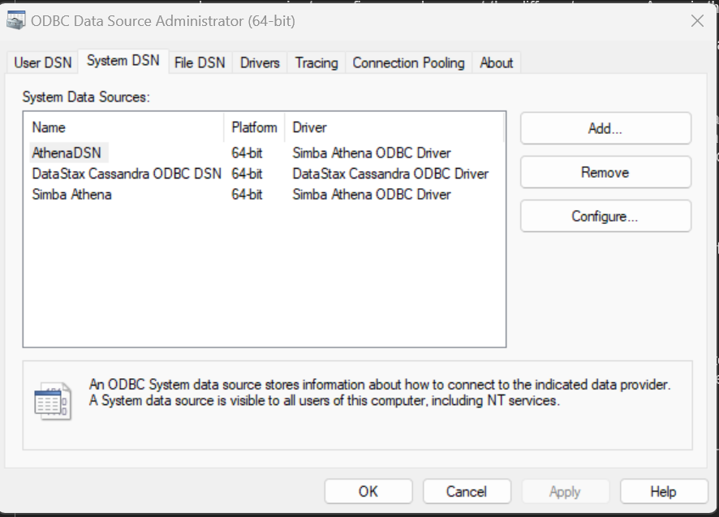
      - Upon getting the driver click on “Add”, which will direct us to a page asking for a new data source click on “ Simba Athena ODBC Driver”
      - Directing us to this page which we will fill in according to our configurations required AWS region : us-east-1 , s3 Outlook location : ( s3 bucket arn) 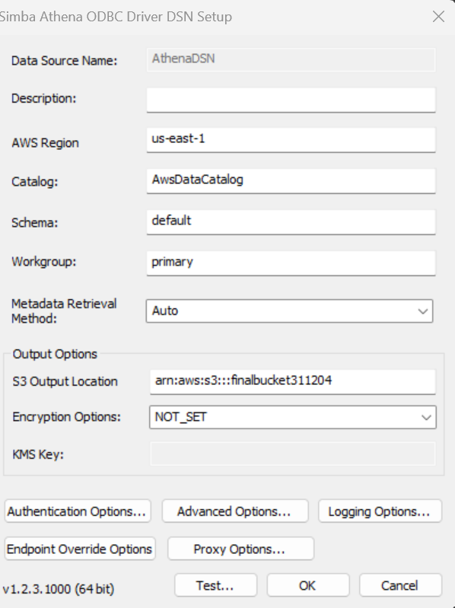
      - After filling in the needed, click on “Authentication Options”
Upon doing so we will need to fill up the needed blanks, this is in accordance to our AWS keys, go into the AWS learner lab and click on “AWS Details” which will show your user: aws_access_key_id, Password: aws_secret_access_key and session token: aws_session_token
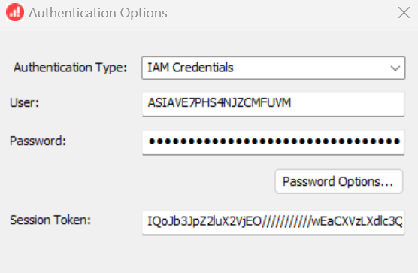
      - Press “ok” and then back to the page we saw in point 6 we will press “test” if the connection is successful it will show a “ success” giving us the green light to move to Power BI
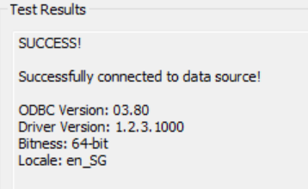
      - Going into Power BI click on “Home” which will direct us to get data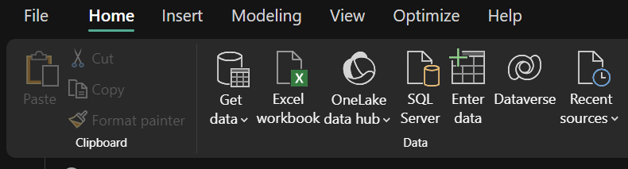
      - Upon getting in and selecting “get data” it will direct us to a “get data” page in which we will search up “ODBC” and then click “connect”
      - We will find the new ODBC driver we made earlier; in my case it is AthenaDSN. Click “ok”
      - Upon clicking and connecting you should be able to see all the files and databases we made in Athena
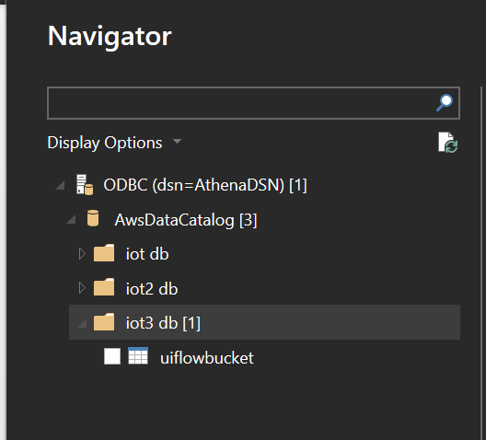
      - Connect then we can go on to visualisation.

Visualisations
Upon anylaysing the data

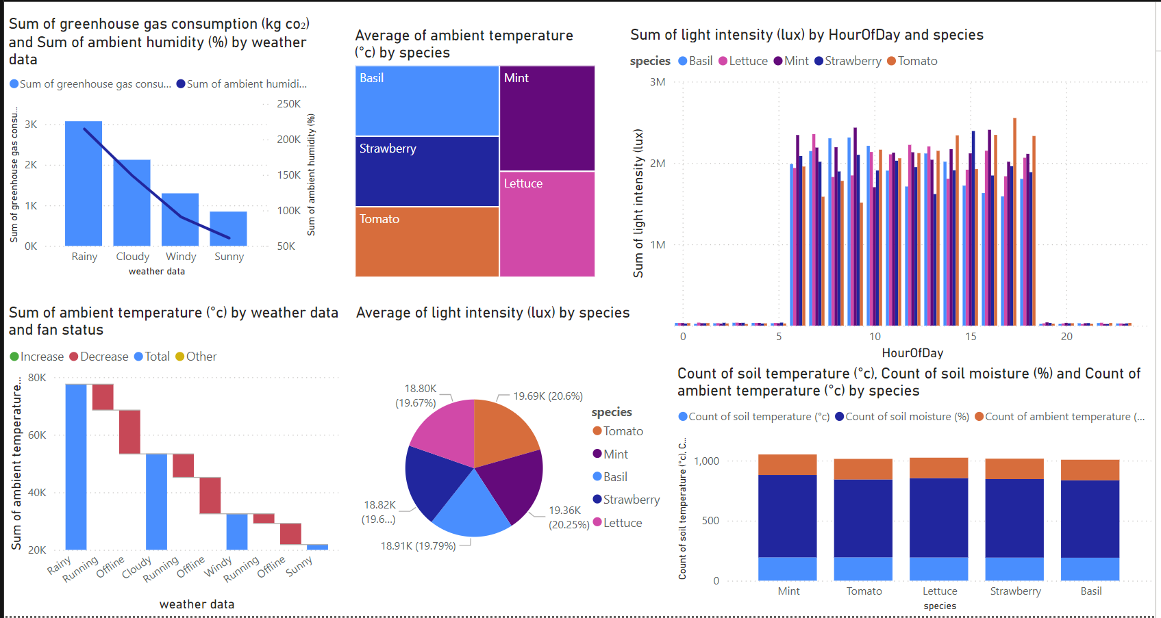

New columns made
    - DayNight - IF(HOUR([Timestamp]) >= 6 && HOUR([Timestamp]) < 18, "Day", "Night")
    - Hourof day - HourOfDay = HOUR([Timestamp])
    - HumidityStress- HumidityStress =
IF(
[ambient humidity (%)] < 40 || [ambient humidity (%)] > 70,
"Stress",
"Optimal"
    - Tempshift - TempDifference = [soil temperature (°c)] - [ambient temperature (°c)]

1. Sum of Greenhouse Gas Consumption (kg CO₂) and Ambient Humidity (%) by Weather Data
This is beneficial in the long run because they demonstrate the external weather conditions and the influence of energy consumption. Highlighting the potential to reduce emissions and align with sustainability goals.
Automate fan operation using real-time weather data. For example:
  - On rainy days: Increase fan usage to offset high humidity.
  - On sunny days: Minimize fan usage to save energy.
  - Use a weather API like OpenWeather to provide real-time data for automation. Fans could be dynamically adjusted based on the weather forecast, further improving efficiency.

2. Average of Ambient Temperature (°C) by Species
Each species (e.g., tomatoes vs. mint) has unique temperature requirements, with tomatoes thriving at higher temperatures.
Positions the system as a precision agriculture tool tailored to specific plant species, ideal for speciality markets like urban vertical farming. Broadens the system's appeal to commercial growers, who may require tailored environmental controls for high-value crops.
  - Use plant-specific optimal temperature thresholds in your system logic.
  - Ensure your IoT sensors continuously monitor the temperature and trigger fan systems based on each species' requirements, ensuring growth efficiency and resource optimisation.

3. Sum of Light Intensity (lux) by Hour of Day and Species
It helps in energy cost optimisation by reducing artificial lighting during peak daylight hours. Enables promotion of your system as an energy-efficient, cost-saving solution that integrates with renewable energy sources like solar panels.
Develop a scheduling algorithm to adjust artificial lighting based on real-time light intensity:
    - Turn off lights during peak daylight hours.
    - Focus artificial lighting during early morning or late evening when natural light is low.
    - Introduce data-driven fan and shade controls to balance light and heat exposure.

4. Sum of Ambient Temperature (°C) by Weather Data and Fan Status
Fans are more critical during rainy and cloudy days for temperature regulation, while sunny days show less dependency due to naturally higher temperatures.
  - Proves the cost-effectiveness of your system by demonstrating selective fan usage based on environmental conditions.
  - Position your system as energy-efficient and capable of reducing operational costs for businesses and households.
  - Implement conditional logic for fan operation:
  - On rainy/cloudy days: Increase fan speed when humidity exceeds 80%.
  - On sunny days: Turn off fans if temperatures are within optimal ranges.
  - Integrate this logic with weather data APIs for dynamic and efficient system performance.

5. Average of Light Intensity (lux) by Species (Pie Chart)
  - Simplifies system scalability by focusing on a universal lighting approach that works for diverse plant species.
  - Attracts a broader customer base, including both individual growers and commercial farms.
  - Use real-time light sensors to maintain consistent light levels for all plants.
  - Display real-time light conditions in a dashboard for user monitoring and optimization. For example, a pie chart visual like this could be directly integrated into the UI of your solution.

6. Count of Soil Temperature (°C), Soil Moisture (%), and Ambient Temperature (°C) by Species
  - Demonstrates that your system is low-maintenance and scalable, making it ideal for diverse applications (e.g., households, eldercare homes, or urban gardens).
  - Markets your system as an all-in-one solution that supports multiple plant types simultaneously.
  - Automate watering and fan controls using soil and ambient conditions. For example:
    - If soil moisture < 40% → Activate watering system.
    - If soil temperature > 30°C and ambient humidity < 60% → Turn on fans.
  - Implement thresholds for soil and temperature conditions in a modular way so that they can be updated without changing the core logic.

Chapter 3 Evaluation/Review

Product
- M5 stack core2
- Earth sensor
- Humidity monitor
- Water pump
- Mini fan unit
- AWS services

Review

M5Stack Core2
- Pros:
  - Responsive and compatible with multiple sensors.
  - Accessible once configured, with Blockly as a highly suitable IDE for development.
  - Reliable performance in edge-to-cloud integrations when payloads are optimized.
- Cons:
  - Limited documentation, especially for advanced configurations.
  - Edge-to-cloud integration using MQTT is constrained by payload size, which can hinder efficiency.

Earth Sensor
- Pros:
  - Accurate in measuring soil moisture and temperature.
  - Allows customization of formulas for specific applications.
- Cons:
  - Does not come pre-configured, requiring time to develop and test formulas.

Humidity Monitor
- Pros:
  - Reliable for measuring ambient temperature, wind speed, and humidity.
  - Versatile and adaptable for various environmental monitoring needs.
- Cons:
  - Requires manual calibration and formula fine-tuning, which can be time-consuming.

Water Pump
- Pros:
  - Simple to configure and operate.
  - Highly reliable with minimal coding required.
- Cons:
  - Performance is dependent on a consistent water source.

Mini Fan Unit
- Pros:
  - Compact, powerful, and easy to use.
  - Straightforward to code for on/off functionality.
- Cons:
  - Limited airflow range due to its small size.

AWS Services
- Pros:
  - Comprehensive suite for data processing, cleaning, automation, and analysis.
  - Robust tools like Lambda and Step Functions streamline workflows.
- Cons:
  - Policies and budget constraints can limit usability.
  - Complex setups for IoT Core and S3 require advanced expertise.

Process

Process Overview

Initial Research and Learning
The project required extensive research and understanding of the M5Stack Core2 and UIFlow. Due to limited documentation on these relatively new tools, we relied on comparisons with older versions of IoT devices and online resources to configure the settings and connections. YouTube tutorials on older devices were particularly helpful in bridging the knowledge gap.
This research phase took approximately two weeks. Along the way, we encountered challenges such as the device frequently breaking down, requiring reconfiguration every few hours. The absence of a SIM card also limited our ability to collect data promptly. The device's sensitivity added an extra layer of complexity, making setup and adjustments more time-consuming.

Sensor Configuration
Working with the ENV III sensors presented its own set of hurdles. The lack of prior documentation or videos on connecting these sensors to the M5Stack Core2 delayed progress. The device ports were incompatible, necessitating constant reconfigurations. We used unique beep sounds for each port to identify and adjust settings accordingly.
Each sensor—temperature, humidity, and soil moisture—required different formulas to ensure accurate readings. This involved accounting for environmental factors and understanding the unique GPIO pin configurations for each sensor. These steps demanded significant time and effort to resolve.

UIFlow and AWS IoT Integration
After successfully testing and connecting the IoT device to UIFlow, we moved on to integrating it with AWS IoT Core. This step involved combining MicroPython and Blockly codes, ensuring seamless interaction between the sensors and AWS IoT without causing system crashes.
One major challenge was managing runtime limitations to prevent device overheating. Additionally, restricted permissions for modifying IAM roles and policies created difficulties in establishing public data transfer configurations. Despite these hurdles, we achieved a successful connection after numerous trials and errors.

AWS Pipeline Implementation
The next step was developing the AWS pipeline. Key considerations included cost efficiency and time constraints, which influenced our design decisions.

S3 Buckets
We created two S3 buckets—one for ongoing data and another for incoming data. The initial challenge was configuring a public bucket while adhering to security standards. We experimented with 5-6 code iterations for bucket policies before achieving a functional configuration. This process took about a week.

Lambda and Data Transfer
Connecting AWS Lambda with IoT Core and S3 proved to be the most challenging aspect of the pipeline. Initially, Python scripts failed to transfer data between buckets due to insufficient IAM permissions. Additional issues arose from incorrect data formatting, which we resolved using the AWS Wrangler library. This allowed us to properly format the data and establish a working Lambda layer.

Athena and Glue
To enable data queries in Athena, we utilized Glue crawlers to process and organize data for analysis. This step was completed without major issues.

Step Functions
Using AWS Step Functions involved significant troubleshooting. Errors arose from inconsistent naming conventions and limitations of our student AWS account. We addressed these by implementing robust failure recovery mechanisms at each step to ensure data integrity and maintain backups.

EventBridge and Analysis
EventBridge integration was relatively straightforward. We configured it to trigger Step Functions at 5-minute intervals, ensuring smooth automation of data workflows.
For data analysis, we chose Power BI as our visualization tool. Its accessibility and flexibility allowed us to interpret results and make real-life applications of our findings easily.

Recommendations for Improvement
A couple of things I would recommend adding on if given the opportunity and time for this project, provided full unrestricted AWS access and timeline would be the following.

Recommendations for System Enhancement
1. Technical Documentation and User Resources
- Provide detailed technical documentation with step-by-step examples to guide users.
- Explore alternative MQTT configurations and payload compression techniques for better data integration and efficiency.
2. Simplified Setup and Pre-Built Features
- Offer pre-configured settings or templates to reduce the time needed for initial setup.
- Include a library of tested formulas and pre-built solutions for common applications to assist users.
3. Calibration and Interface Improvements
- Develop pre-calibrated options or provide clear setup guides to streamline the initial calibration process.
- Create a more intuitive user interface for easier fine-tuning and customisation of settings.
4. Safeguards and Modularity
- Incorporate safeguards such as low water level indicators to prevent interruptions during operation.
- Design modular components to allow scalability for larger systems.
5. Enhanced Hardware Features
- Introduce larger or adjustable fan units to cover broader areas effectively.
- Integrate variable-speed control for more flexibility in fan operations.
6. Cost-Effective Policy Configurations and IoT-S3 Integration
- Simplify policy configurations to suit small-scale projects and reduce costs.
- Enhance user guides for IoT-S3 integration with practical examples and troubleshooting steps.

Advanced Features for Future Development
1. Implementing Amazon Redshift
- Complex Analysis: Perform advanced analytics, such as correlation studies, with the robust querying capabilities of Redshift.
- Optimized Storage: Utilize its columnar storage for faster processing compared to Athena.
- Multi-Source Data Integration: Redshift can centralize IoT sensor data with external sources like weather APIs, plant databases, and user inputs.
2. Leveraging Blockchain Technology
- Reliability and Trust: Ensure transparency and data integrity with the blockchain’s tamper-proof structure.
- Smart Contracts: Automate processes like data tracking and provenance validation.
- Green Certification: Support accountability for green certification bodies.
- Tokenization: Incentivize sustainable practices by introducing a green token economy.
3. Real-Time Data Processing with AWS Kinesis
- Real-Time Feedback: Process and analyse live data streams for immediate updates on garden conditions.
- Trend Analysis: Identify real-time spikes or sudden trends to react promptly.
4. Deploying Amazon SageMaker
- Machine Learning Models: Use predictive analytics to forecast outcomes such as humidity trends, watering schedules, and energy consumption.
- Pattern Recognition: Identify meaningful patterns for improved decision-making.
5. Establishing a Data Lake
- Centralized Storage: Create a data lake to store raw and processed data from S3 for flexible access and processing.
- Enhanced Metrics: Develop meaningful processing metrics for actionable insights.
- Integration of External Data: Combine weather forecasts and other external datasets for a comprehensive view.

Reflection

Lessons Learnt and Insights Gained
Throughout this project, I have learned a lot of lessons on myself and the devices. I will be breaking this down into 3 different topics, project management, research and development, and implementations.

Project Management
This project was uncharted territory for everyone involved, making it both daunting and exciting. Initially, there was uncertainty about the right approach. To manage this, I introduced several baseline rules for both myself and my team.
- Timeline and Task Allocation:
We developed a detailed timeline by breaking down the project into smaller milestones, aligning with the final due date. Tasks were allocated based on individual strengths, enabling us to leverage each member’s skill set effectively. This strategy ensured tasks were manageable and realistic. Regular updates and progress checks were conducted every two days with the teacher in charge, fostering accountability and momentum.
- Conflict Resolution and Collaboration:
When faced with conflicting opinions or technical hurdles, we encouraged open discussions to understand each perspective. Tasks that seemed particularly challenging were split and approached collaboratively, reducing the time needed for debugging. Debugging included researching solutions, identifying hidden issues, and ensuring the integrity of the codebase. These practices strengthened team communication, allowing us to defuse conflicts by evaluating the feasibility and timing of proposed solutions.
- Lessons in Communication:
By maintaining a rational, empathetic approach, we resolved misunderstandings and created a supportive and friendly team dynamic. This taught us the importance of balancing professionalism with camaraderie to keep morale high.

Research and Development
One of the major hurdles was working with the M5Stack Core2. This device presented numerous issues, including reconfiguration challenges, software uncertainties, and port compatibility problems.
- Research Strategy:
Extensive research into the device’s capabilities, compatibility with software, and prior projects was instrumental in overcoming these obstacles. Experimenting with different configurations and studying successful implementations gave us clarity and direction.
- Adaptability with AWS:
Working with AWS also involved significant trial and error. Choosing the right pipeline required balancing factors like speed, accessibility, and cost. Restrictions due to student permissions and lab configurations limited our options, forcing us to think creatively and devise alternative solutions within those boundaries. These limitations pushed us to innovate and adapt, though they were often time-intensive.

Implementation
This phase tested our patience and ability to adapt.
- Debugging in Action:
Debugging wasn’t just fixing errors—it was about understanding the root cause of issues, testing solutions thoroughly, and making sure we didn’t break anything else in the process. It was frustrating at times, but we got better at spotting patterns and narrowing down problems.
- Working Around Constraints:
Limited permissions and resources meant we had to get creative. We found ways to work within the boundaries while still meeting project goals. This was time-consuming but rewarding when things finally worked.

Personal Growth
Looking back, this project taught me so much about myself and how to handle tough situations.
- Teamwork and Leadership:
I learned how to organize tasks, bring people together, and make sure everyone felt heard. I also realized how important it is to keep the team environment friendly but focused.
- Staying Calm Under Pressure:
There were moments when things felt overwhelming, but staying composed and taking it step by step helped me stay on track.
- Thinking Beyond the Project:
This project wasn’t just about technical work—it also got me thinking about how technology can benefit communities, not just businesses. It made the work feel more meaningful.

References/ Bibliography
Agata.olbrycht@grapeup.com. (2023, August 18). How to manage an m5stack core2 for AWS - C/C++. Grape Up. https://grapeup.com/blog/how-to-manage-an-m5stack-core2-for-aws-part-2-c-c/#
Amazon Athena - User Guide. (n.d.-a). https://docs.aws.amazon.com/pdfs/athena/latest/ug/athena-ug.pdf
DavMartEs, & ajb2k3. (2019, April 30). [solved]black screen error. M5Stack Community. https://community.m5stack.com/topic/950/solved-black-screen-error
Dev@kodzilla.pl. (2023, July 20). How to manage an m5stack core2 for AWS - Micropython. Grape Up. https://grapeup.com/blog/m5stack-core2-controller-for-aws-micropython/#
Digiponta, ajb2k3, & Pandian.nano. (2023, July 26). I can’t connect the M5 stack Core2 to WIFI in my program. M5Stack Community. https://community.m5stack.com/topic/5416/i-can-t-connect-the-m5-stack-core2-to-wifi-in-my-program
Examples of Amazon S3 bucket policies - Amazon Simple Storage Service. (n.d.-b). https://docs.aws.amazon.com/AmazonS3/latest/userguide/example-bucket-policies.html
IOT analytics - AWS IOT analytics - AWS. (n.d.-c). https://aws.amazon.com/iot-analytics/
MicroPython documentation and referencesℑ. MicroPython documentation and references - UIFlow2 Programming Guide master documentation. (n.d.). https://uiflow-micropython.readthedocs.io/en/latest/index.html
Rashed Talukder, R. B. (n.d.). Aws Iot Kit. AWS IoT Kit. https://core2-for-aws-docs.m5stack.com/en/getting-started/prerequisites/windows/
Slumnit, Lukasmaximus, ajb2k3, & Wetzel, M. (2019, February 21). Not connecting to WIFI - first setup. M5Stack Community. https://community.m5stack.com/topic/675/not-connecting-to-wifi-first-setup
What is Amazon EC2? - amazon elastic compute cloud. (n.d.-d). https://docs.aws.amazon.com/AWSEC2/latest/UserGuide/concepts.html
YouTube. (n.d.-a). YouTube. https://www.youtube.com/watch?v=axN3O232WN0
YouTube. (n.d.-b). YouTube. https://www.youtube.com/watch?v=Og6fYoyiTIk&list=PLgvIHLw9-cydbokzAKhi7lWcOVJ67RRTR
YouTube. (n.d.-c). YouTube. https://www.youtube.com/watch?v=b-Hn02VQ1RQ

Appendix A1: Terms of Reference

MP_TOR (Rachel Robin Fernandes).docx

Appendix A2: Weekly Progress Report
To access my weekly please click on the embedded link below:
Weekly combined.docx

